**E-CONFINEMENT SERVICE SYSTEM**

By

CHIA KAI YI

A REPORT

SUBMITTED TO

Universiti Tunku Abdul Rahman

in partial fulfillment of the requirements

for the degree of

BACHELOR OF COMPUTER SCIENCE (HONOURS)

Faculty of Information and Communication Technology

(Kampar Campus)

MAY 2021

**UNIVERSITI TUNKU ABDUL RAHMAN**

|  |
| --- |
| REPORT STATUS DECLARATION FORM **Title**: E-Confinement Service System_________________________________  **Academic Session**: 2022/01  I ___________CHIA KAI YI_________________________  **(CAPITAL LETTER)**  declare that I allow this Final Year Project Report to be kept in  Universiti Tunku Abdul Rahman Library subject to the regulations as follows:   1. The dissertation is a property of the Library. 2. The Library is allowed to make copies of this dissertation for academic purposes.   Verified by,  _________________________  (Author’s signature) (Supervisor’s signature)  **Address**:  No 59A, Lorong Intan 14,  ­Taman Intan Mas, 36000 Ts. Yeck Yin Ping  Teluk Intan, Perak Supervisor’s name  **Date**: 18/4/2022 **Date**: ____________________ |

|  |  |  |  |
| --- | --- | --- | --- |
| **Universiti Tunku Abdul Rahman** | | | |
| Form Title : **Sample of Submission Sheet for FYP/Dissertation/Thesis** | | | |
| Form Number: **FM-IAD-004** | Rev No.: **0** | Effective Date: **21 JUNE 2011** | Page No.: **1 of 1** |

**FACULTY/INSTITUTE* OF INFORMATION COMMUNICATION AND TECHNOLOGY**

**UNIVERSITI TUNKU ABDUL RAHMAN**

Date: __18/4/2022_____

**SUBMISSION OF FINAL YEAR PROJECT /DISSERTATION/THESIS**

It is hereby certified that _CHIA KAI YI*_* (ID No: __***18ACB01343***) has completed this final year project entitled “____*E-CONFINEMENT SERVICE SYSTEM _ _*” under the supervision of __Ts. Yeck Yin Ping__(Supervisor) from the Department of ____________________,

Faculty of ___ Information Communication And Technology___.

I understand that University will upload softcopy of my final year project / dissertation/ thesis* in pdf format into UTAR Institutional Repository, which may be made accessible to UTAR community and public.

Yours truly,

__

CHIA KAI YI

# DECLARATION OF ORIGINALITY

I declare that this report entitled “**E-CONFINEMENT SERVICE SYSTEM**” is my own work except as cited in the references. The report has not been accepted for any degree and is not being submitted concurrently in candidature for any degree or other award.

Signature : 

Name : CHIA KAI YI

Date : 18/4/2022

# ACKNOWLEDGEMENTS

I would like to express my sincere thanks and appreciation to my supervisor, Ts. Yeck Yin Ping and my moderator, Ts. Tan Teik Boon who have given me this bright opportunity to engage in a mobile application development project. Besides that, they have given me a lot of guidance in order to complete this project. When I was facing problems in this project, the advice from them always assists me in overcoming the problems. It is my first step to establish a career in mobile application field. A million thanks to my supervisor and moderator.

Finally, I must say thanks to my family and my friends for their love, support and continuous encouragement throughout the course.

**ABSTRACT**

This project details an attempt to create a mobile application to provide a platform for the buyers and Confinement Lady to find and sell for the confinement service. This application is targeted to work on Android device. In this project will develop an enhancement of existing application. The core function of this is to help the new mother to search for the available confinement lady around the them. This function is implemented by using the GPS tracking system. Other than that, there would be additional features which can make the users more convenient while using the application.

Developing this project involves the usage of Visual Studio Code as its integrated development environment. The framework used to develop this mobile application is Flutter. Flutter is an open-source UI software development kit created by Google. It is used to develop cross platform applications for Android, iOS, Linux, macOS, Windows, Google Fuchsia, and the web from a single codebase. The interface and most of features would be utilize much of Dart programming. An android device is used for testing.

The methodology of used to develop this project is Agile Development approach. This approach includes Planning, Design, Development, Testing, Deployment which helps to provide deploy the final application that minimize bug after few iterations of the Planning, Design, Development, and Testing phases.

# TABLE OF CONTENTS

REPORT STATUS DECLARATION FORM ii

DECLARATION OF ORIGINALITY iv

ACKNOWLEDGEMENTS v

ABSTRACT vi

TABLE OF CONTENTS vii

LIST OF TABLES xi

LIST OF FIGURES xii

LIST OF ABBREVIATIONS xvi

Chapter 1 Introduction 1

1.1 Problem Statement & Motivation 1

1.2 Project Objectives 3

1.3 Project Scope 5

1.4 Contribution 7

1.5 Report Organization 8

Chapter 2 Literature Review 9

2.1 Review of the Technologies 9

2.1.1 Hardware Platform 9

2.1.2 Database 10

2.1.3 Programming Language 11

2.1.4 Algorithm 11

2.1.4.1 Haversine Algorithm 11

2.1.4.2 Vincenty Algorithm 12

2.1.5 Comparison between Haversine algorithm and Vincenty algorithm 14

2.2 Review of Existing Systems/Applications 15

2.2.1 28Days 15

2.2.2 Confinement Care Malaysia PLT 18

2.2.3 NannySOS Confinement Nanny Agency 21

2.2.4 Star Confinement Nanny 23

2.2.5 PEM Confinement Nanny Agency 26

2.2.6 Comparison between the similar application with the proposal system 29

2.3 Discussion 30

Chapter 3 System Methodology/Approach 32

3.1 System Design Diagram/Equation 33

3.1.1 System Architecture Diagram 33

3.1.1.1 Buyer Interface Flow 33

3.1.1.2 Service Provider Interface Flow 34

3.1.1.3 Admin Interface Flow 34

3.1.1.4 Database Management Flow 34

3.1.2 Use Case Diagram and Description 36

3.4 System Design 37

3.4.1 System Framework 37

3.4.2 Use Case Diagram 38

3.4.3 Use Case Description 39

3.4.3.1 Sign up Module (Customer) 39

3.4.3.2 Sign in Module (Customer) 39

3.4.3.3 Select Confinement Service Module 40

3.4.3.4 View Order Summary Module 41

3.4.3.5 Rate Confinement Lady Module 42

3.4.3.6 Report Problem Module 42

3.4.3.7 Sign Up Module (Confinement Lady) 43

3.4.3.8 Sign in Module (Confinement Lady) 43

3.4.3.9 View Rating Module 44

3.4.3.10 Navigation Module 44

3.4.4 Activity Diagram 46

3.4.4.1 Sign Up Module (Customer) 46

3.4.4.2 Sign In Module (Customer) 46

3.4.4.3 Select Confinement Service Module 47

3.4.4.4 View Order Summary Module 50

3.4.4.5 Rate Confinement Lady Module 51

3.4.4.6 Report Problem Module 52

3.4.4.7 Sign up Module (Confinement Lady) 53

3.4.4.8 Sign in Module (Confinement Lady) 54

3.4.4.9 Navigation Module 55

3.4.4.10 View Rating Module 56

3.4.5 Sequence Diagram 57

3.5 Verification Plan 65

3.6 Implementation Issues and Challenges 68

3.7 Timelines 69

Chapter 4 Preliminary Work 71

4.1 Implementation of Firebase into the project. 71

4.2 Start-up User Interface 72

4.3 Sign in User Interface 73

4.4 Sign-up User Interface 74

4.5 Profile Detail User Interface 75

4.6 Homepage (Customer) 77

4.7 Profile (Customer) 79

4.8 Order Now (Customer) 80

4.9 Confinement lady Selection Page (Customer) 82

4.10 Service Type User interface (Customer) 83

4.11 Default Confinement Service User Interface (Customer) 84

4.12 Customize Confinement Service User Interface (Customer) 86

4.13 Pending Order Page (Customer) 87

4.14 Progress Order Page (Customer) 88

4.15 History Page (Customer) 90

4.16 Homepage (Confinement Lady) 91

4.17 Profile Page (Confinement Lady) 92

4.18 Pending Order Page (Confinement Lady) 93

4.19 Progress Order Page (Confinement Lady) 94

4.20 History Page (Confinement Lady) 95

Chapter 5 Conclusion 96

BIBLIOGRAPHY 97

Appendix A Biweekly Report 100

Appendix B Poster 106

Appendix C Plagiarism Check Result 107

Appendix D FYP 1 Checklist 111

# LIST OF TABLES

|  |  |  |
| --- | --- | --- |
| **Table Number** | **Title** | **Page** |
| Table 2.6.1 | Table of Comparison n Between Reviewed System and Proposed System | 18 |
| Table 3.2.1.1 | Software Tools for Development | 24 |
| Table 3.4.3.1 | Use Case description for Customer Sign Up Module | 29 |
| Table 3.4.3.2 | Use Case description for Customer Sign in Module | 29 |
| Table 3.4.3.3 | Use Case description for Select Confinement Service Module | 30 |
| Table 3.4.3.4 | Use Case description for Choose Default Confinement Service Package module | 30 |
| Table 3.4.3.5 | Use Case description for Customize Confinement Service Package | 31 |
| Table 3.4.3.6 | Use Case description for View Order Summary Module | 31 |
| Table 3.4.3.7 | Use Case description for Rate Confinement Lady Module | 32 |
| Table 3.4.3.8 | Use Case description for Report Problem Module | 32 |
| Table 3.4.3.9 | Use Case description for Confinement Lady Sign Up Module | 33 |
| Table 3.4.3.10 | Use Case description for Confinement Lady Sign in Module | 33 |
| Table 3.4.3.11 | Use Case description for View Rating Module | 34 |
| Table 3.4.3.12 | Use Case description for Navigate to Customer’s house | 34 |

# LIST OF FIGURES

|  |  |  |
| --- | --- | --- |
| **Figure Number** | **Title** | **Page** |
| Figure 2.1.1.1 | Main interface of 28Days | 4 |
| Figure 2.1.1.2 | Main interface of 28Days | 5 |
| Figure 2.1.1.3 | E-commerce platform on 28Days | 5 |
| Figure 2.2.1.1 | Main Interface of Confinement Care Malaysia PLT | 7 |
| Figure 2.2.2.1 | Guidance for customers to book confinement lady | 8 |
| Figure 2.2.2.2 | Services listed with graphical visual | 8 |
| Figure 2.3.1.1 | Main interface of NannySOS | 10 |
| Figure 2.3.2.1 | Contact Interface of NannySOS | 11 |
| Figure 2.4.1.1 | Main Interface of Star Confinement Nanny | 12 |
| Figure 2.4.2.1 | Reservation System of Star Confinement Nanny | 13 |
| Figure 2.5.1.1 | Main Interface of PEM Confinement Nanny Agency | 15 |
| Figure 2.5.2.1 | Services listed in Graphical View | 16 |
| Figure 2.5.2.2 | Review from Customers of PEM Confinement Nanny Agency | 16 |
| Figure 3.1.1 | Agile Software Development Phases | 23 |
| Figure 3.4.1.1 | System Framework of E-confinement Service System | 27 |
| Figure 3.4.2.1 | Use Case Diagram of E-Confinement Service System | 28 |
| Figure 3.4.4.1 | Activity Diagram for Sign Up Module | 35 |
| Figure 3.4.4.3 | Activity Diagram for Select Confinement Service Module | 36 |
| Figure 3.4.4.4 | Activity Diagram for Select Default Confinement Service Package Module | 38 |
| Figure 3.4.4.5 | Activity Diagram for Select Customize Confinement Service Package Module | 39 |
| Figure 3.4.4.6 | Activity Diagram for View Order Summary Module | 39 |
| Figure 3.4.4.7 | Activity Diagram for Rate Confinement Lady Module | 40 |
| Figure 3.4.4.8 | Activity Diagram for Report Problem Module | 41 |
| Figure 3.4.4.9 | Activity Diagram for Confinement Lady Sign Up Module | 42 |
| Figure 3.4.4.10 | Activity Diagram for Confinement Lady Sign in Module | 42 |
| Figure 3.4.4.11 | Activity Diagram for Navigate to Customer’s House | 43 |
| Figure 3.4.4.12 | Activity Diagram for View Rating Module | 44 |
| Figure 3.4.5.1 | Sequence Diagram for Sign Up Module | 45 |
| Figure 3.4.5.2 | Sequence Diagram for Sign in Module | 46 |
| Figure 3.4.5.3 | Sequence Diagram for Select Confinement Service Module | 47 |
| Figure 3.4.5.4 | Sequence Diagram for View Order Summary Module | 48 |
| Figure 3.4.5.5 | Sequence Diagram for Rating Confinement Lady Module | 49 |
| Figure 3.4.5.6 | Sequence Diagram for Report Problem Module | 50 |
| Figure 3.4.5.7 | Sequence Diagram for Navigate to Customer House module | 51 |
| Figure 3.4.5.8 | Sequence Diagram for View Rating Module | 52 |
| Figure 3.5.1 | Login Verification | 53 |
| Figure 3.5.2 | Sign Up Verification | 54 |
| Figure 3.5.3 | Password Verification in Sign in and Sign Up | 54 |
| Figure 3.5.4 | Email Verification in Sign in and Sign Up | 55 |
| Figure 3.7.1 | Timeline for FYP 1 | 57 |
| Figure 3.7.2 | Timeline for FYP 2 | 58 |
| Figure 4.1.1 | Firebase Setup (1) | 59 |
| Figure 4.1.2 | Firebase Setup (2) | 59 |
| Figure 4.2.1 | Splash Screen | 60 |
| Figure 4.2.2 | Welcome Page | 60 |
| Figure 4.3.1 | Sign in User Interface | 61 |
| Figure 4.3.2 | Source code of Sign in Function | 62 |
| Figure 4.4.1 | Sign-up user interface | 62 |
| Figure 4.4.2 | Source code for Sign up Function | 63 |
| Figure 4.5.1 | Profile Detail User Interface (1) | 63 |
| Figure 4.5.2 | Profile Detail User Interface (2) | 63 |
| Figure 4.5.3 | Source code for add the data into Firebase | 64 |
| Figure 4.5.4 | Data that stored in Firebase | 64 |
| Figure 4.6.1 | Homepage (Customer) | 65 |
| Figure 4.6.2 | Source code of the Buttons | 66 |
| Figure 4.7.1 | Profile Interface (1) | 67 |
| Figure 4.7.2 | Profile Interface (2) | 67 |
| Figure 4.7.3 | Source code for update profile data | 68 |
| Figure 4.8.1 | Order Now User Interface (1) | 68 |
| Figure 4.8.2 | Order Now User Interface (2) | 68 |
| Figure 4.8.3 | Date Picker | 69 |
| Figure 4.8.4 | Source code for date picker | 69 |
| Figure 4.9.1 | Confinement Lady Selection Page | 70 |
| Figure 4.10.1 | Service Type User Interface | 71 |
| Figure 4.11.1 | Default Confinement Service User Interface | 72 |
| Figure 4.11.2 | Dialog Box | 72 |
| Figure 4.11.3 | Source code of the dialog box | 73 |
| Figure 4.11.4 | Source code of add the default service package | 73 |
| Figure 4.12.1 | Customize Confinement Service User Interface | 74 |
| Figure 4.12.2 | Source code of add the customize service package | 75 |
| Figure 4.13.1 | Pending Order Page | 75 |
| Figure 4.13.2 | Pending Order Page Detail | 75 |
| Figure 4.14.1 | Progress Order Page | 76 |
| Figure 4.14.2 | Progress Order Page Detail | 76 |
| Figure 4.14.3 | Source code to delete the order | 76 |
| Figure 4.14.4 | Rating dialog | 77 |
| Figure 4.14.5 | Source code of the Submit button | 78 |
| Figure 4.15.1 | History Page | 78 |
| Figure 4.15.2 | History Page Detail | 78 |
| Figure 4.16.1 | Homepage (Confinement Lady) | 79 |
| Figure 4.17.1 | Profile Interface (3) | 80 |
| Figure 4.17.2 | Profile Interface (4) | 80 |
| Figure 4.18.1 | Pending Order Page | 81 |
| Figure 4.18.2 | Pending Order Detail Page | 81 |
| Figure 4.19.1 | Progress Order Page | 82 |
| Figure 4.19.1 | Progress Order Detail Page | 82 |
| Figure 4.20.1 | History Page | 83 |
| Figure 4.20.2 | History Detail Page | 83 |

# LIST OF ABBREVIATIONS

GUI – Graphical User Interface

GPS – Global Positioning System

API – Application Program Interface

IDE – Integrated Development Tools

a.k.a. – also known as

# Introduction

## 1.1 Problem Statement & Motivation

* + 1. **Dissatisfaction of the provided reservation system in the web-based application.**

The dissatisfaction of the reservation system provided by the system due to the automatically assign confinement services to the buyer without letting them to customize the confinement services. Most of the reservation system provide the default confinement service packages to the buyer to make sure they can maximize their revenue. As a result, the buyer unable to customize their preferable confinement service packages when they are using the system. Consequently, buyer will have bad impression and experience on the provide confinement service that might affect the reputation of the service provided.

* + 1. **Poor Quality of the confinement lady’s service.**

The challenge of implementing a confinement lady rating system due to the poor quality of confinement service. The performance of the confinement lady will not be monitored without the rating system. Hence, the Mother are not credibility and accountability of the confinement lady. As a result, the Mother might have the chance to pick a confinement lady with low credibility and accountability which will cause the Mother have a bad experience on the confinement service that might affect the reputation of the service platform.

* + 1. **Unable to find the nearby confinement lady.**

Buyer who find the confinement lady might wish to find a nearby confinement lady since the flavor or taste of the food cooked by the confinement lady might be huge differences and not suit to the buyer’ taste due to the different culture or cooking style based on the states and areas. However, they did not know if there are any nearby confinement lady around them as they cannot browse any confinement lady near them. Thus, it is difficult for them to go search for the nearby confinement lady since they do not have an application or website to browse for the confinement lady.

## 1.2 Project Objectives

1. **To integrate the customize confinement service system in the application for the improve the level of customization in the reservation of confinement service.**

Satisfaction of the customer is important as it is foundation of a successful business. Therefore, a fully customizable on selecting confinement service package system will be implement to the mobile-based application. Buyer able to choose their desired service package or customize their own desired service package and confinement ladies able to set up their own and unique confinement service packages in this mobile application. As a result, this system able to bring convenient and satisfaction to both users.

1. **To implement the rating system for monitoring the rating given to the confinement lady.**

The rating system will be implemented into the system to monitor the performance of the confinement lady consistently. Buyers are allowed to rate their experience with confinement lady at the end of the confinement service. This feature is used to enhance the buyer’s experience in order to ensure a supreme service is provided to the them. As a result, the confinement lady’s performance is improved in order to receive higher rating from the buyer as the rating is reflect to the confinement service experience and the credibility from this confinement lady.

1. **To apply Haversine algorithm for getting the nearest confinement ladies around the buyer**

The Haversine algorithm will be applied into this project in order to search for the nearest confinement ladies around the Mother. This algorithm used to calculate the shortest distance between two coordinate which is useful for this scenario. Buyers can view the list of confinement ladies that around him by using this feature.

## 1.3 Project Scope

The project scopes cover the implementation of the current technology to solve the problems that mentioned at the 1.2 Problem Statements. This application is a mobile-based application that run in Android-platform. This project will be developing with the Flutter framework and using the Dart programming language.

1. **Customizable confinement service system.**

The mobile-based application will implement a customizable service system to let the user customize their confinement service package. After the buyers select his desired confinement lady and the date of confinement, buyers will be directed to the user interface that allow them to select the different confinement service packages provided by the confinement ladies. If the buyers wish to customize their own confinement service package, they are allowed to customize the confinement service by selecting the customize button at the bottom part. This feature allows the buyers to get their desired confinement service without paying extra for the service that unnecessary.

1. **Rating system with photos and videos.**

Rating system feature will be implemented into the system to allow buyers to rate their experiences with the confinement service provided by the confinement lady. It is used to rate the performance of the confinement lady by uploading the videos, photos, comments and the rating about the confinement services they experienced. The videos, photos, comments and the rating uploaded by the buyers will be displayed on the rating section of the particular confinement lady for further references.

1. **GPS Tracking System.**

GPS tracking system is a feature that used the GPS service in the device to help the buyers find the confinement ladies around them by computing the distance between them. The system will access the geolocation of buyers and confinement ladies and calculate the distance between them by applied the Haversine algorithm. Haversine algorithm used to calculate the shortest distance between two points on a sphere using their latitudes and longitudes measured along the surface. It will benefit the buyers who are willing to find confinement lady who is near to them.

## 1.4 Contribution

This mobile application is being develops for the users to use it as a platform for looking for confinement service and the job opportunity for the free-lancing confinement lady.

In this project, the customizable reservation service system will be implemented into system which allow the user to choose for their desired service confinement service package without need to pay any extra money to experience some certain service that they do not want to include in their service package. This feature also allowed the confinement lady to sell their unique confinement service package which can make the service more diversified. The customizable reservation system able to resolve the dissatisfaction of the users about the current provided reservation system.

The GPS tracking system able to provide a lot of job opportunity to the confinement lady. They able to find the customer through the mobile application. This mobile application provides a platform for the confinement lady to find the reliable customer sources. Besides, this mobile application provides a secure way for the user to find the confinement lady. The user that uses this platform only can find the confinement lady that had registered in the E-confinement service system which mean that the data of the confinement lady that registered in the database will be verified before shown in the customers selecting page.

The rating system able to prevent the other customer from experiences some bad confinement service provided by the low credibility and accountability confinement lady. The rating system let the customers to differentiate which confinement lady has the better credibility and better responsibility to handle the confinement service. As a result, the quality of the confinement service able to be increase as the performance of the confinement lady able to monitor directly from the rating system.

## 1.5 Report Organization

This report is organised into 7 chapters**: Chapter 1 Introduction, Chapter 2 Literature Review, Chapter 3 System Methodology/Approach, Chapter 4 System Design, Chapter 5 System Implementation, Chapter 6 System Evaluation and Discussion, and Chapter 7 Conclusion and Recommendation.** The first chapter is the introduction of this project which includes problem statement and motivation, project objectives, project scope, project contribution, and report organisation. The second chapter is the literature review carried out on several existing web applications in the market related to the confinement service provider to evaluate the strengths and weaknesses of each existing system. The strength and weakness of algorithm studied also included in this chapter. The third chapter is the system methodology that include all the system design diagrams like system architecture diagram, use case diagrams, activity diagrams and the sequence diagrams. The fourth chapter is regarding the details on how to implement the design of the system. Furthermore, the fifth chapter reports the about how the system is been implemented and the screenshot of the application interface. Chapter sixth is about the evaluation of the overall system. Lastly, the conclusion and recommendation will be discussed in chapter seventh.

# Literature Review

## 2.1 Review of the Technologies

### 2.1.1 Hardware Platform

**2.1.1.1 Visual Studio Code**

Visual Studio Code, also commonly known as VS Code, is a source code editor made by Microsoft for Windows, Linux and macOS. Visual Studio Code combines the simplicity of a code editor with what the developer needs for their core edit-build-debug cycle. The features included in this IDE support for debugging, syntax highlighting, intelligent code completion, snippets, code refactoring, and embedded Git. Users also can change the appearance, theme and preferences of the IDE by install extensions from the store.

**2.1.1.2 Android Studio**

Android Studio is the official IDE for the Google’s Android operating system. This IDE is available for multiple platform which are Windows, Linux and macOS. The features available in this IDE such as Gradle-based build support, Android-specific refactoring and quick fixed, Lint tools to catch the performance, usability, version compatibility and etc. The main feature of this IDE used in this project is Android emulator. This feature is used as an emulator to debug the source code.

**2.1.1.3 PC Model**

|  |  |
| --- | --- |
| System | Information |
| Operating system | Microsoft Windows 10 Pro |
| Processor | Intel(R) Core (TM) i5-10400 |
| Graphic Card | GTX 1660 Super |
| CPU | 6 Core(s), 12 Logical Processor(s) |
| Memory (RAM) | 16 GB |
| System Type | 64-bit operating system, x64-based PC |

***Table 2.1.1.3.1 Detail Information of the PC Model***

**2.1.1.4 Mobile Phone**

1. Mobile Phone Model: Huawei Nova 5T

|  |  |
| --- | --- |
| System | Information |
| Operating system | Android |
| Android Version | Android 10.0 |
| Resolution | 2340 x 1080 pixels |
| Processor | Huawei Kirin 980 |
| Memory (RAM) | 8 GB |
| Internal storage | 128 GB |

***Table 2.1.1.4.1 Detail Information of the Mobile Device***

1. Mobile Phone Model: Android Virtual Device

|  |  |
| --- | --- |
| System | Information |
| Operating system | Android |
| Android Version | Android 9.0 |
| Resolution | 2280 x 1080 pixels |
| Processor | Unknown |
| Memory (RAM) | 1536 MB |
| Internal storage | 2048 MB |

***Table 2.1.1.4.2 Detail Information of the Mobile Device***

### 2.1.2 Database

**2.1.2.1 Google Firebase**

Google Firebase is a platform developed by Google for creating the backend for mobile and web application. It also provides the feature for web hosting. It was originally an independent company that founded in 2011. Google acquired this Firebase in 2013 and now this is their flagship their offering the backend services for the application development.

### 2.1.3 Programming Language

The programming language used to develop this project is Dart. Dart programming language first released date at 2013. Dart is the programming language used to code Flutter app which is used to build the native application. Google had the first release of the Flutter 1.0 in December 2018, after having it in beta testing mode for more than 18 months. Dart is a programming language as well as a mobile app development platform. Ecma (ECMA-408) approved it as a standard, and it's used to develop just about everything on the web, servers, desktops, and, of course, mobile apps.

### 2.1.4 Algorithm

#### 2.1.4.1 Haversine Algorithm

**2.1.4.1.1 Description**

Haversine algorithm is widely used to compute the shortest distance between two points on a sphere using the latitudes and longitudes along the earth surface. [17] The Haversine algorithm can be expressed in the following formula:



***Figure 2.1.4.1.1.1 Formula of Haversine Algorithm***

r = radius of earth (6371 km)  = latitude of the two points

d = distance between two point  = longitude of the two points

**2.1.4.1.2 Strengths**

Haversine algorithm provide a simpler calculation. The computation time is faster and reduces the battery drainage of the mobile phone.

**2.1.4.1.3 Weaknesses**

However, Haversine algorithm does not provide the high accuracy as Vincenty algorithm offers.

#### 2.1.4.2 Vincenty Algorithm

**2.1.4.2.1 Description**

Vincenty algorithm was developed by Thaddeus Vincenty (1975a) for calculating the geodesic distances between two points (latitudes and longitudes) on an ellipsoidal model of the Earth.

This algorithm includes a direct and an inverse method where:

* Direct Method:

It computes the location of a point that is a given distance and azimuth from another point

* Inverse Method:

It computes the geographical distance and azimuth between two given points.

For example, the Inverse Method outputs λ after assigning several constants including the length of the semi-major axis, length of the semi-minor axis, flattening, latitude coordinates, reduced latitudes, etc. The aim of the method is to minimize the value of the output λ (i.e. when the results converge to a desired degree of accuracy):

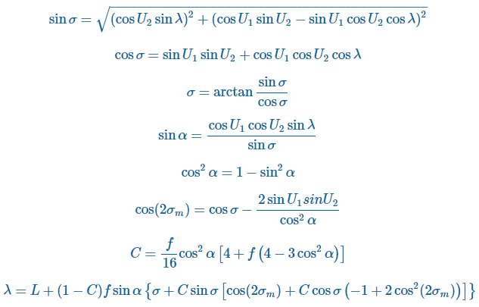

***Figure 2.1.4.2.1.1 Formula of Vincenty Algorithm***

When the difference between the current value of λ and the value of λ from the previous iteration is less than the convergence tolerance then the final stage of the Inverse Method can be executed:

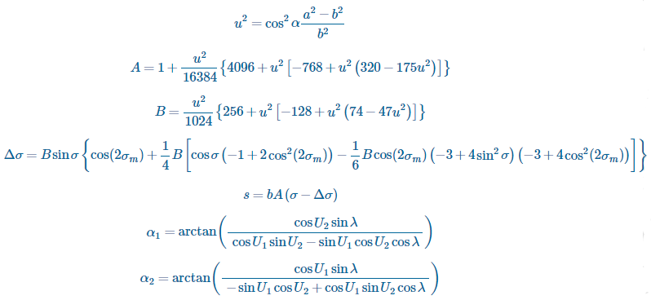

***Figure 2.1.4.2.1.2 Formula of Vincenty Algorithm***

**2.1.4.2.2 Strengths**

The accuracy of the result using Vincenty algorithm is more accurate compared to Haversine algorithm.

**2.1.4.2.3 Weaknesses**

Vincenty algorithm is more computationally intensive, therefore the performance is slower and the battery drain is higher compared to Haversine algorithm

### 2.1.5 Comparison between Haversine algorithm and Vincenty algorithm

|  |  |  |
| --- | --- | --- |
|  | Haversine algorithm | Vincenty algorithm |
| Computation Time | Short | Long |
| Complexity | Low | High |
| Battery consumption | Low | High |
| Accuracy | Low | High |

***Table 2.1.5.1 Table of Comparison Between Haversine Algorithm And Vincenty Algorithm***

## 2.2 Review of Existing Systems/Applications

### 2.2.1 28Days

**2.2.1.1 Description**

The 28Days is the Malaysia 1st Online Postnatal Care Service Platform. It is a trusted online confinement service search tool dedicated to help new moms or mum-to-be find a reliable and the right postnatal care provider or also known as ‘Pui Yuet’. This website is founded by a mother of four children who named Ianie Chong. One of the reasons that urge Ianie to run this system is the bad experience during her pregnancy. During her pregnancy, she had a lot of bad experience of the entire process of hiring a Pui Yuet. So instead of solving this situation, she decides to run a platform that could provide the right Pui Yuet for all of the new mom or mom-to-be. This website mainly helps the moms to find the suitable confinement ladies or nannies in Malaysia. In fact, moms can request to change the confinement lady in the event that the one you paired are not a good match with you.

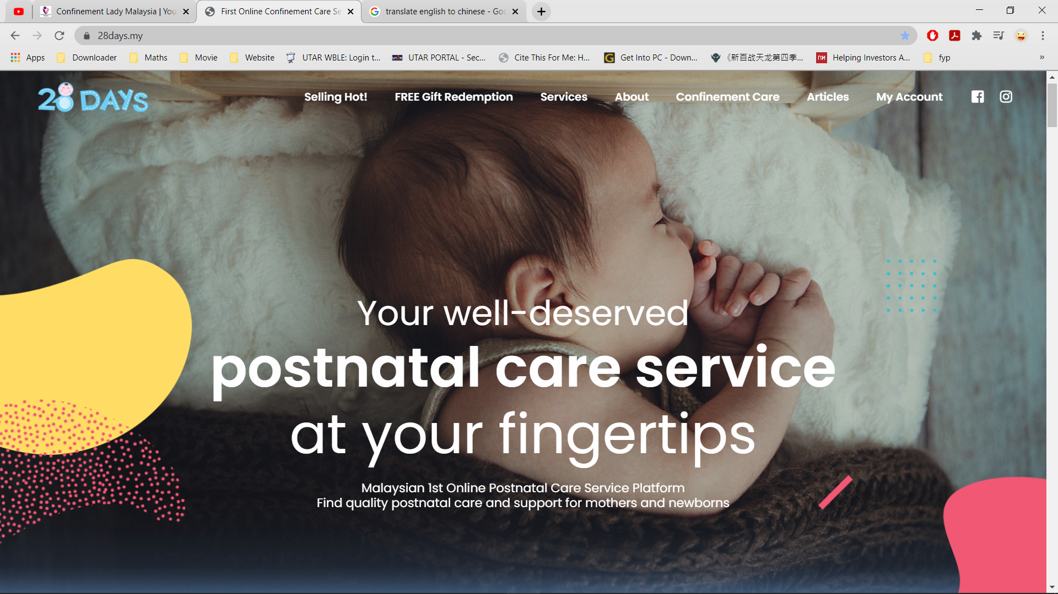

***Figure 2.2.1.1.1 Main interface of 28Days.***

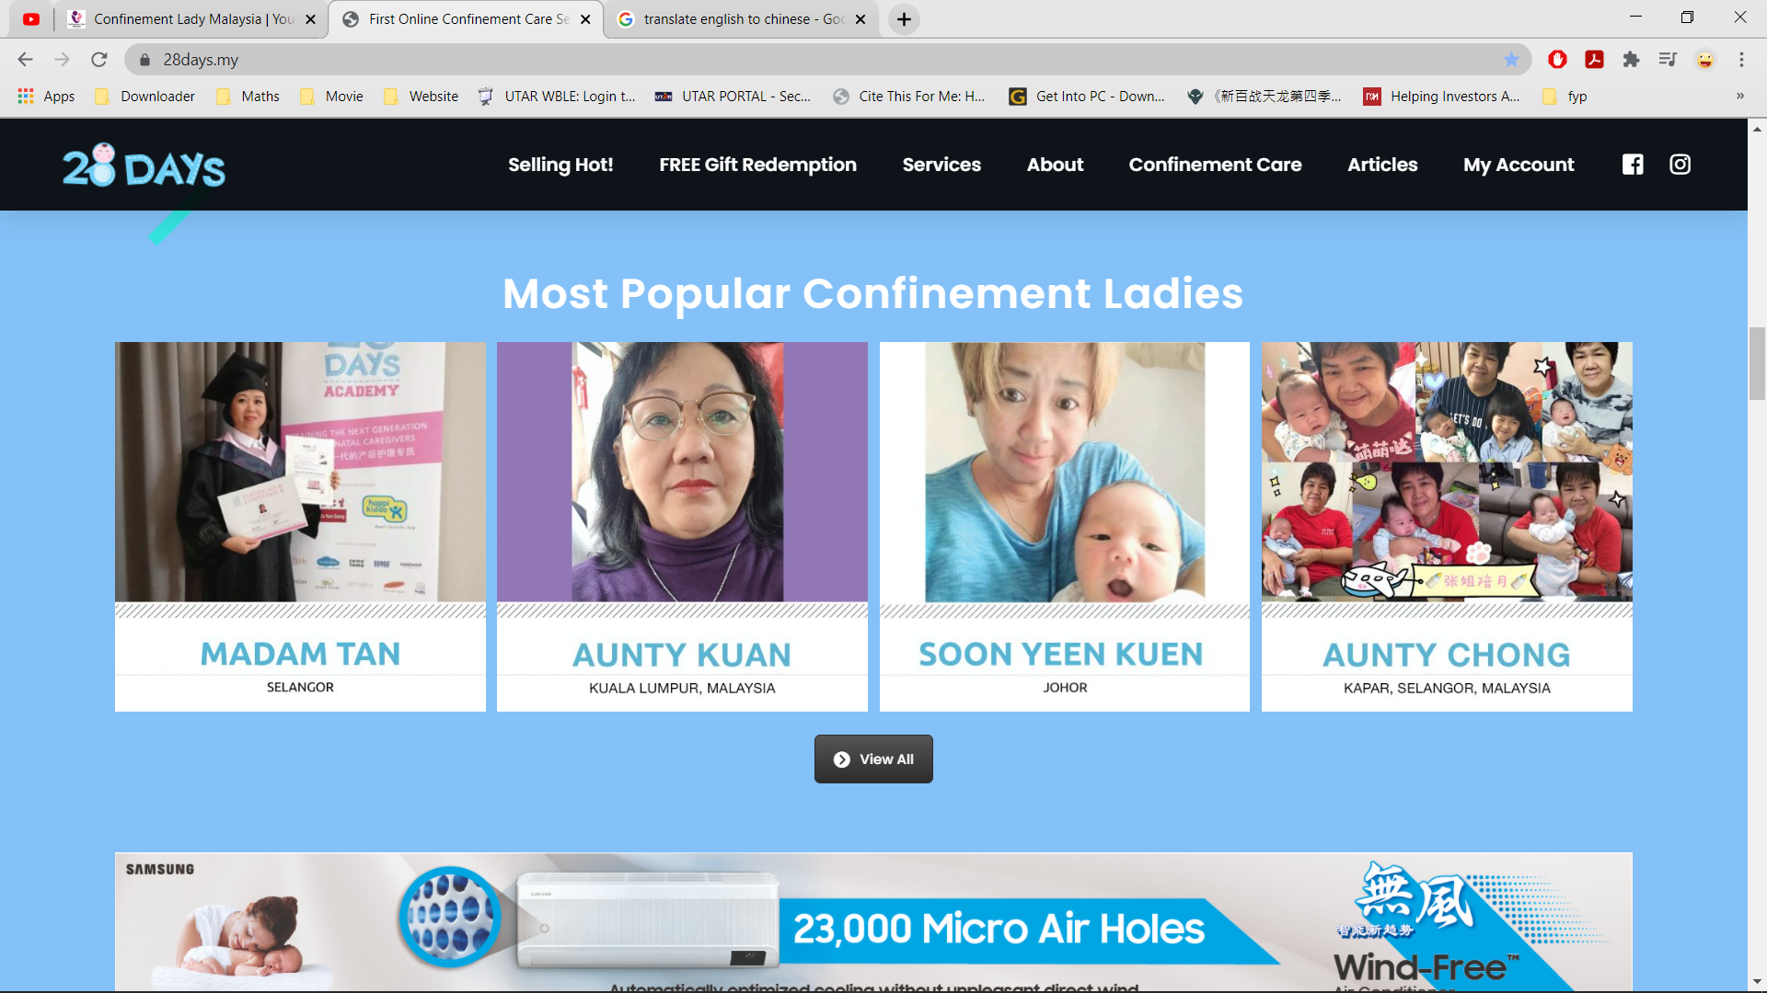

***Figure 2.2.1.1.2 Main interface of 28Days.***

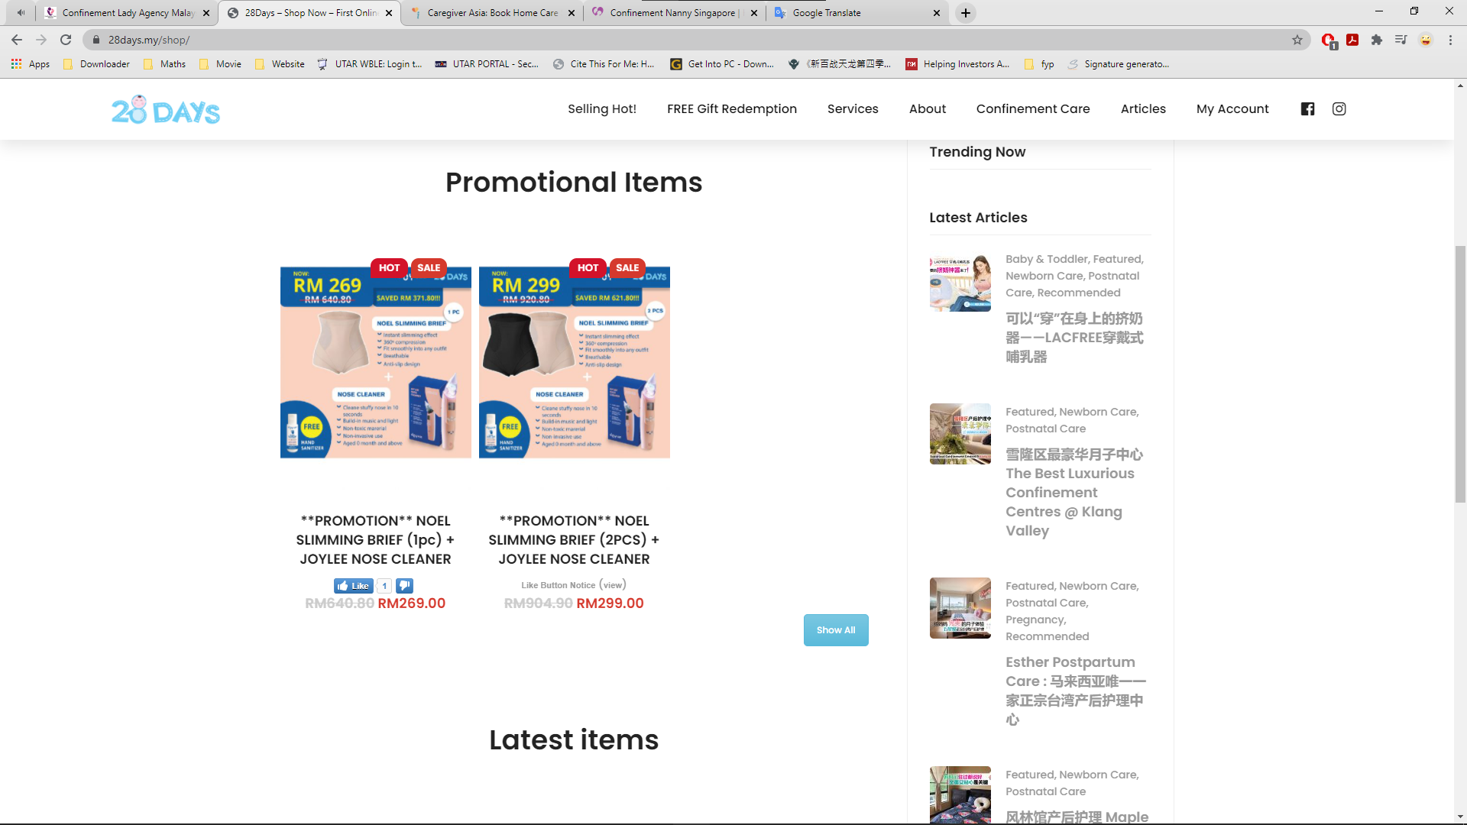

***Figure 2.2.1.1.3 E-commerce platform on 28Days.***

**2.2.1.2 Strengths**

The GUI of this platform is quite simple and easy for the user to use even for those users who does not have very well knowledge about the computer also can handle and operate it. Other than this, the platform has list out the most popular confinement ladies in their main interface. This feature could help the new moms to compare the services between both different confinement ladies and help them to choose out their desired Pui Yuet. Besides, this website also provides an e-commerce platform for the retailer to sell their commodity on the website.

**2.2.1.3 Weaknesses and Limitations**

However, 28Days does not provide some examples of the photo of the confinement lady taking care of the baby and moms. This could be worrying the users since they could not see any evidence that can proof the quality of the confinement service. Another weakness of this platform did not provide the 24/7 standby chat service for the customers. This could cause the office could not instantly receive the feedback or the problem faced by their customers during the confinement service period. Besides, 28Days did not provide review site to let the users write down review. This might cause the potential customers change their mind to hire confinement lady through their platform since they do not have any good review.

**2.2.1.4 Suggestions and Recommendations**

28Days could provide the photo of the confinement lady during the training session or the photo of real scenario that confinement lady taking care of the new moms and baby at their website to proof the professional of their workers. Besides, 28Days can implement the live chat system into their website so they could receive the message from their customers and reply them in real time. Next, the developer can build in a section to display all the review and rating of the service from the customers on their page to proof the quality of their service so that the confinement service center can attract more customers.

### 2.2.2 Confinement Care Malaysia PLT

**2.2.2.1 Description**

Confinement Care Malaysia PLT is an Online Clients-to-Confinement Care Services Provider in Malaysia. Their vision is to help every new mother in achieving a stress-free confinement, by providing Quality Customer Service at affordable fees, all in one organized portal. Confinement Care Malaysia PLT mainly providing the following service which is: coordinating the prompt arrival of a confinement lady to your home when your newborn arrives, providing professional massage services to help new mothers recover and rejuvenate after pregnancy and childbirth and providing professional consultant advice to the first-time. Their confinement service coverage area mainly located at Klang Valley, Penang, and Singapore. The design of this website is quite simple and clearly for those elder people to understand.

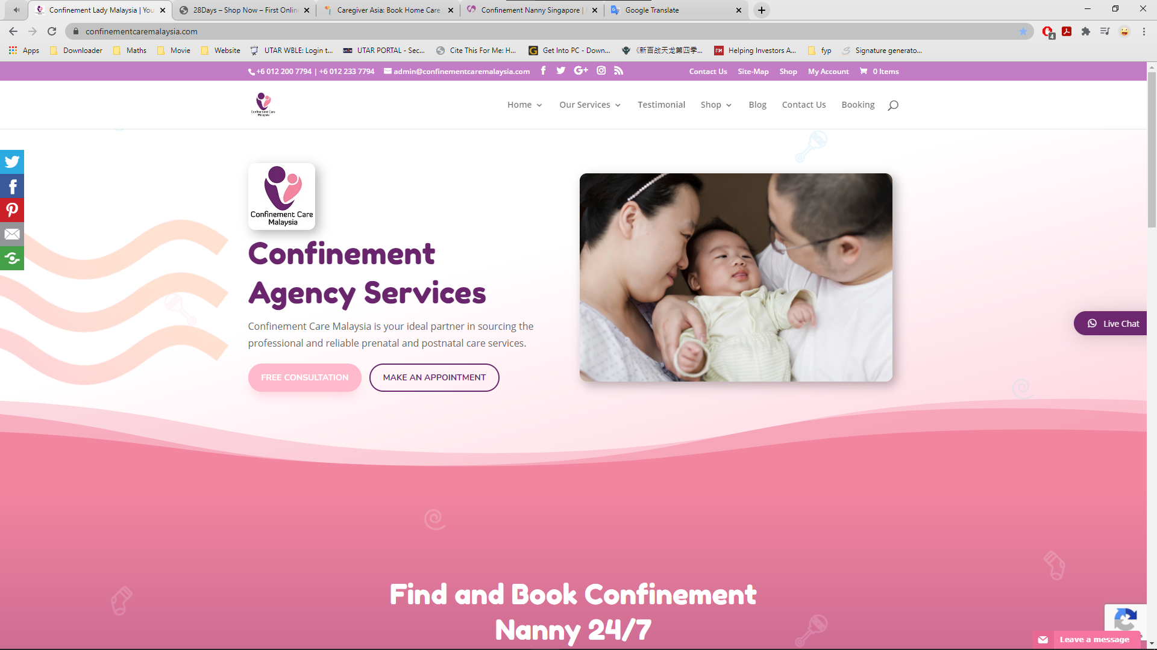

***Figure 2.2.2.1.1 Main Interface of Confinement Care Malaysia PLT.***

**2.2.2.2 Strengths**

The guidance to find and book confinement lady in this website is stated clearly with short and simple in the main page, which made other people easy to understand. Besides, this website also provides the e-platform to sell the confinement product on the website. Another strength that needs to mention is this website has listed out all of that service graphically on their page to emphasize the service they provide.

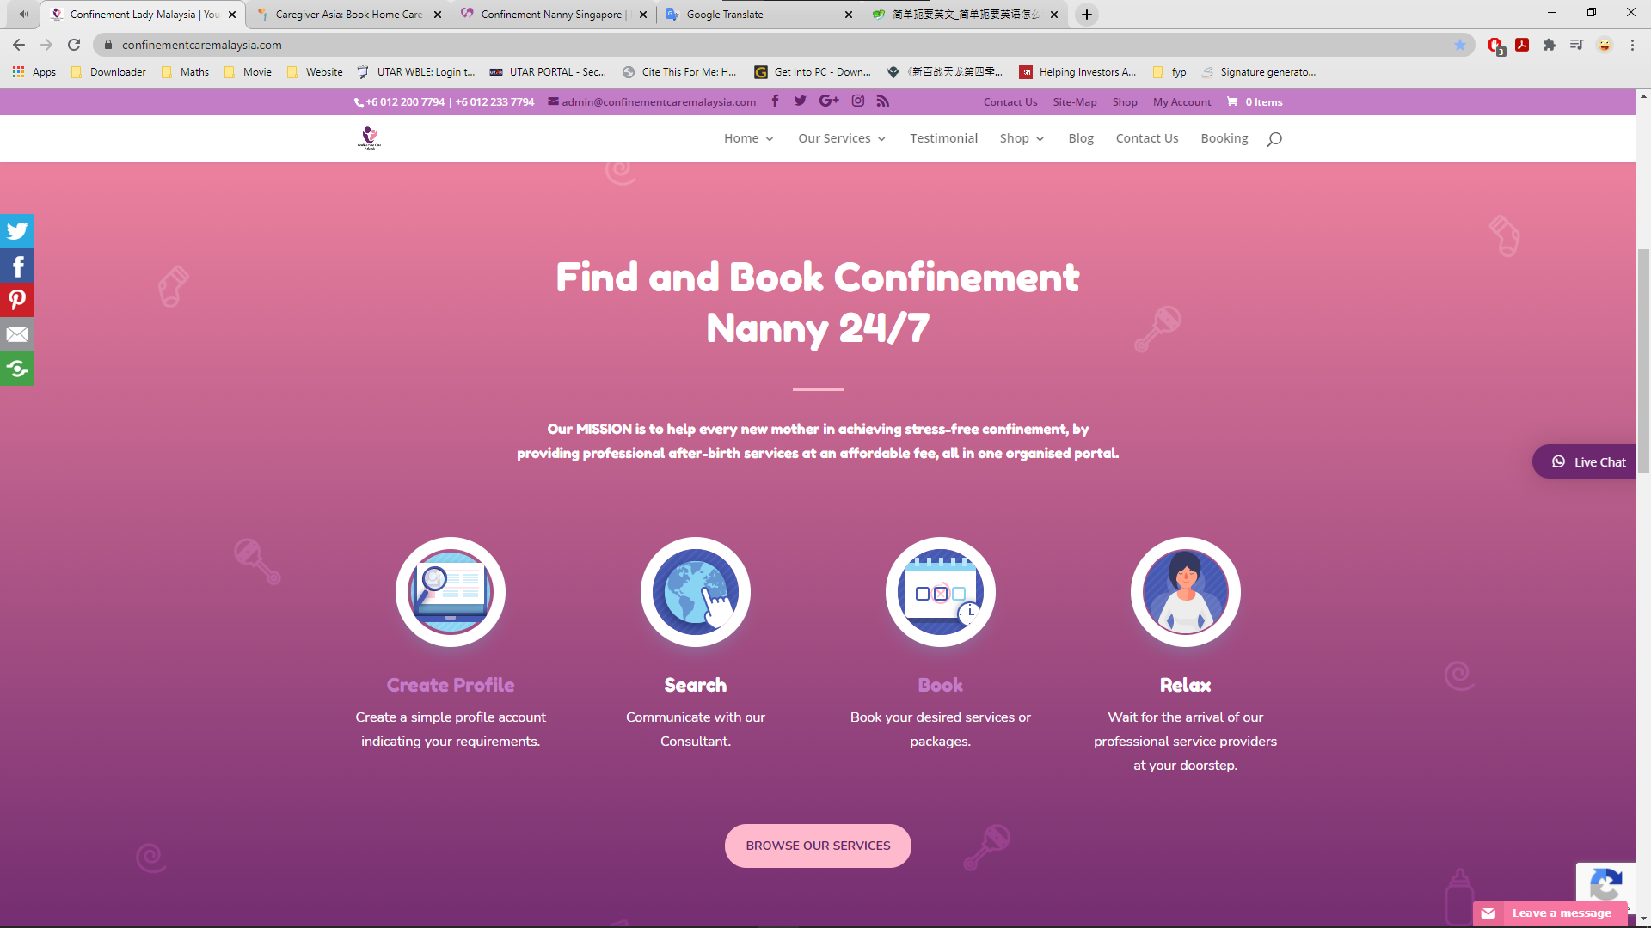

***Figure 2.2.2.2.1 Guidance for customers to book confinement lady.***

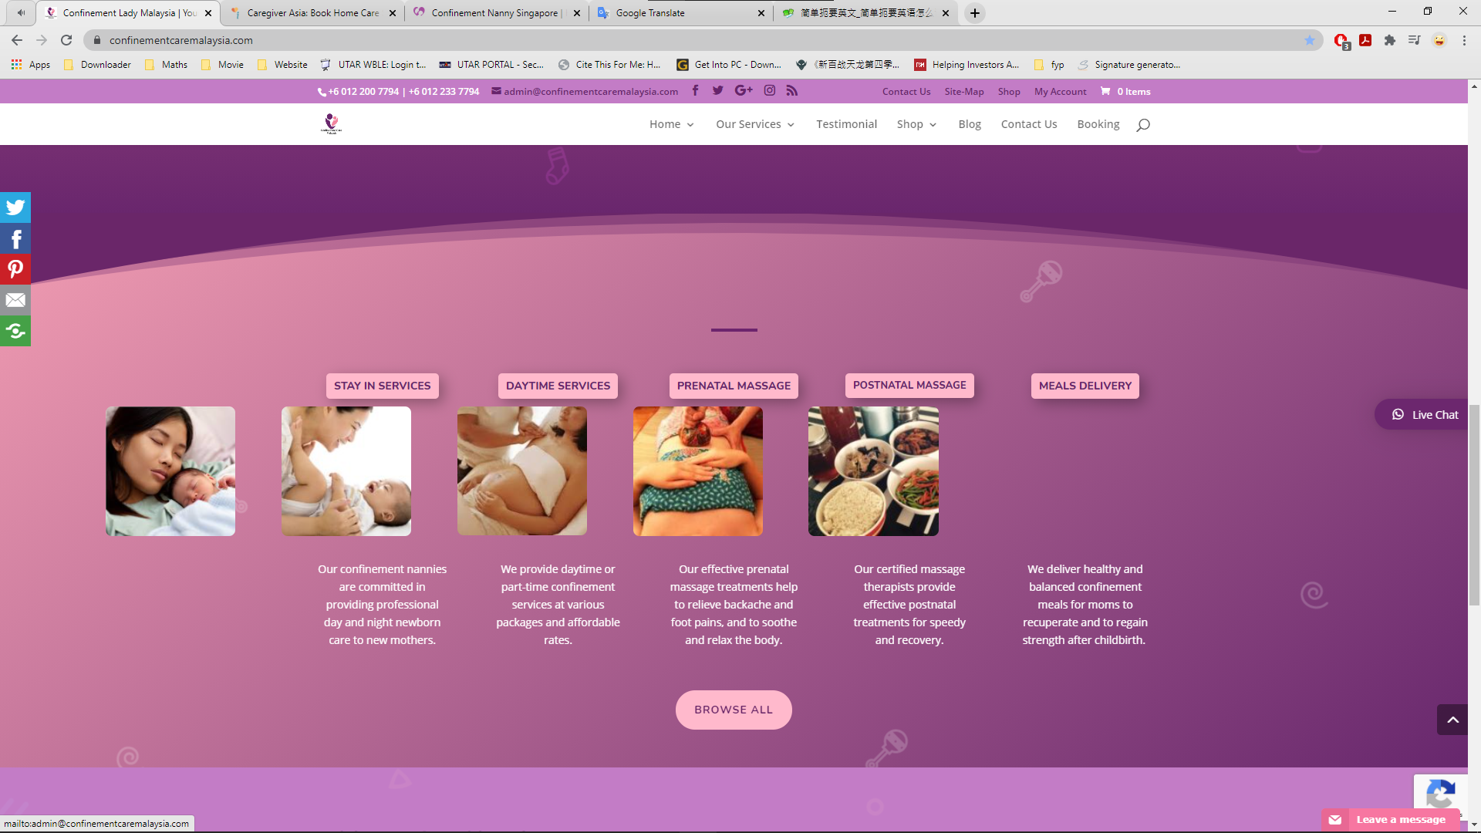

***Figure 2.2.2.2.2 Services listed with graphical visual.***

**2.2.2.3 Weaknesses and Limitations**

This website does not have the pop out notification features on the device. The customers have to self-check the email to for the confirmation of the booking instead of straightly pop out the confirmation notification on their device. Next, this system does not provide detail of the confinement nanny for the user but just random assigning a nanny to the customers.

**2.2.2.4 Suggestions and Recommendations**

The website could apply the pop out notification feature into the website so in the future customers could instantly being notify from the portal once their application is being accepted. Next, the website can add in the detail of confinement lady like name, case handled, experiences into the portal for the customers to have a better view or recognition about the confinement lady they going to hire.

### 2.2.3 NannySOS Confinement Nanny Agency

**2.2.3.1 Description**

NannySOS is a professional confinement nanny agency in Singapore that established since 2011. It registered and approved by the Ministry of Manpower (MOM) to help facilitate the employment such as applying confinement nanny work permit for Malaysian confinement nanny. NannySOS provides confinement services to help mothers with full recovery after childbirth and taking good care of the baby. All nannies from NannySOS confinement nanny agency are professionally trained with at least 3 years of experience (Confinement Nanny Singapore, 2021).

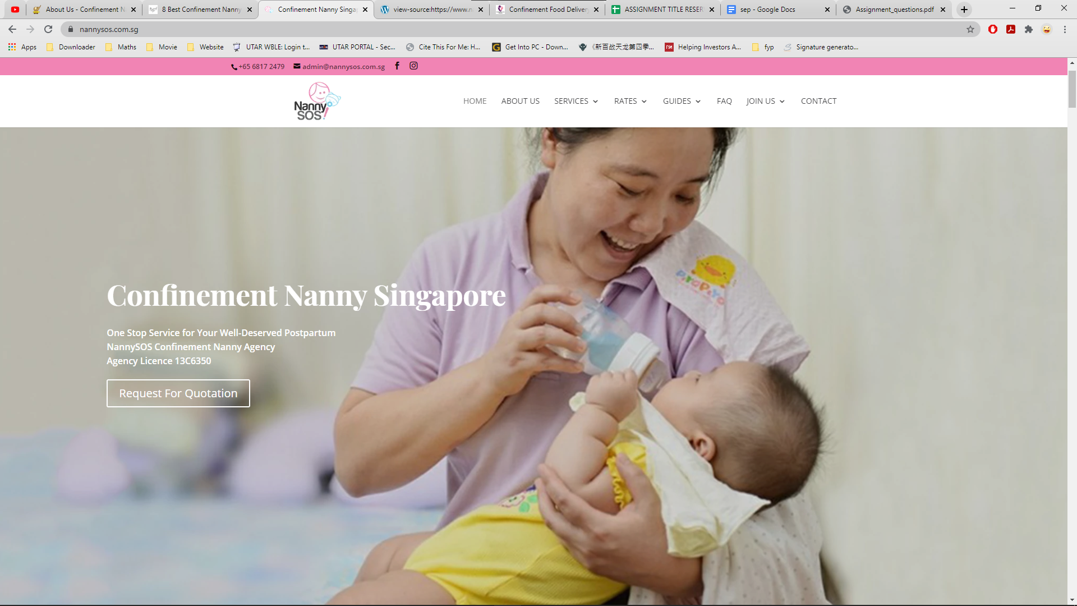

***Figure 2.2.3.1.1 Main interface of NannySOS.***

**2.2.3.2 Strengths**

In the main interface of this website, the agency will provide the provide platform for the recruitment for confinement nanny whereas other websites do not have this feature. The detail of the food menu like the number of meals provided and the price of the meals is clearly stated and align orderliness in the table. Besides, NannySOS also provide the graphical view of its agency location which supported by Google Maps.

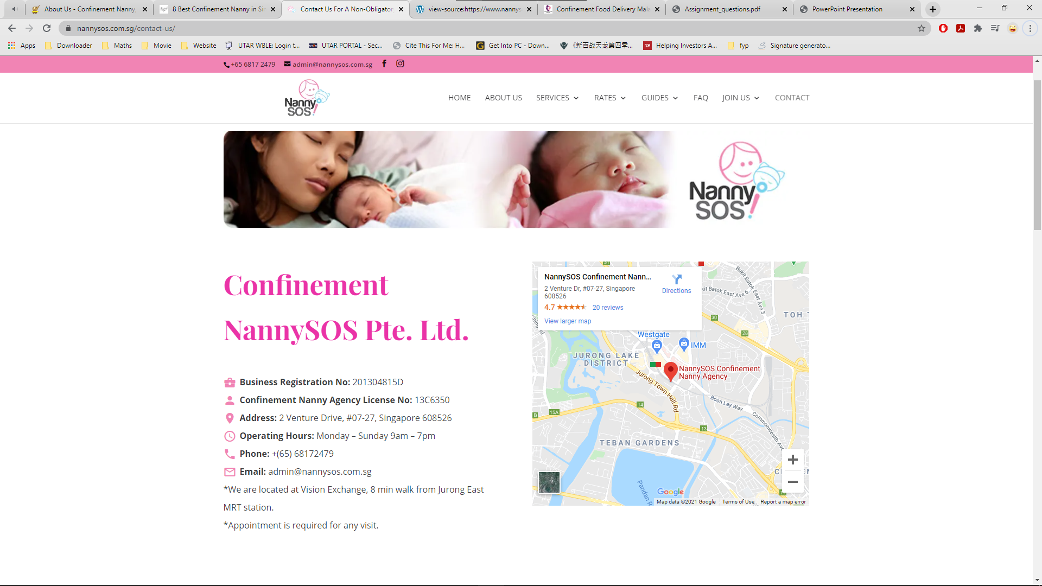

***Figure 2.2.3.2.1 Contact Interface of NannySOS.***

**2.2.3.3 Weaknesses and Limitations**

However, NannySOS did not provide the feature that shown the available confinement lady for the customers to choose. This could not provide the satisfying choice for the customers to choose for their desired confinement lady. NannySOS did not provide the e-commerce platform to sell the relevant confinement items which also cause them lost one of the ways to gain the profit. Besides, live chat system did not implement in the system.

**2.2.3.4 Suggestions and Recommendations**

NannySOS could implement a section that consist all of the available confinement ladies on their website for the customers to choose. Besides, NannySOS can implement a platform to let the seller sell their item on their website. Lastly, NannySOS could build the live chat system or insert a link to direct their customer to their own chat system so they could communicate with their customer instantly.

### 2.2.4 Star Confinement Nanny

**2.2.4.1 Description**

Star Confinement Nanny is specialized in providing quality confinement nannies to post-natal moms and newborns which established since 2013. Their confinement nannies are the modern nannies who are had at least 5-1- years set and full experiences. As such, they are excellent in doing both traditional confinement practices and modern confinement practices for moms and caring for newborns. All of their nannies are selected based on good working record, cleared reference check and a MUST too possess good attitude. Especially one of their nannies had earn an award for the Best Service Confinement Nannies in year 2018. Confinement Nanny seek to become a one of the best confinement agencies in Singapore. They grow from a solid foundation and constantly seek opportunities to grow & expand.

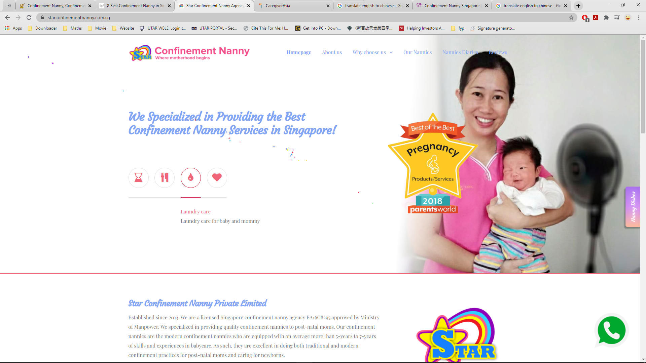

***Figure 2.2.4.1.1 Main Interface of Star Confinement Nanny.***

**2.2.4.2 Strengths**

Star Confinement Nanny had an interesting feature in its reservation system. It allows user or customer to make the reservations with agency through the calendar on their website. Besides, Star Confinement Nanny also provide different kind photo of their confinement meals on their website to attract the customers to order the meals from their agency. Besides, Star Confinement Nanny had posted the nanny diaries on their webpage to let the new moms and their family to understand what actual the confinement lady does to take care the mummy and baby during whole of the confinement period.

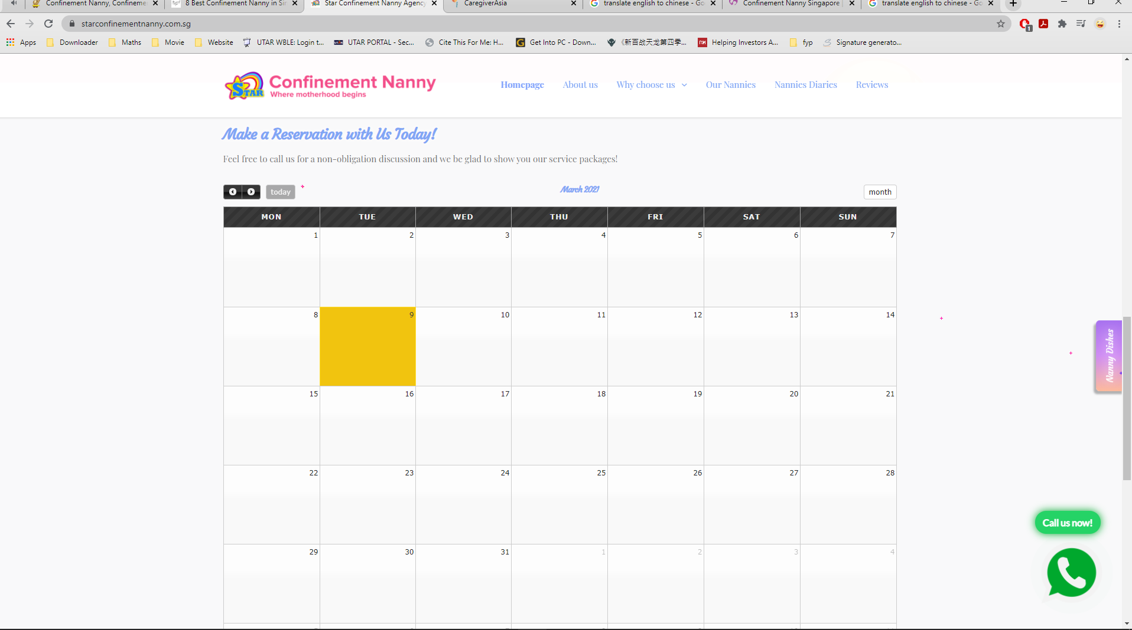

***Figure 2.2.4.2.1 Reservation System of Star Confinement Nanny.***

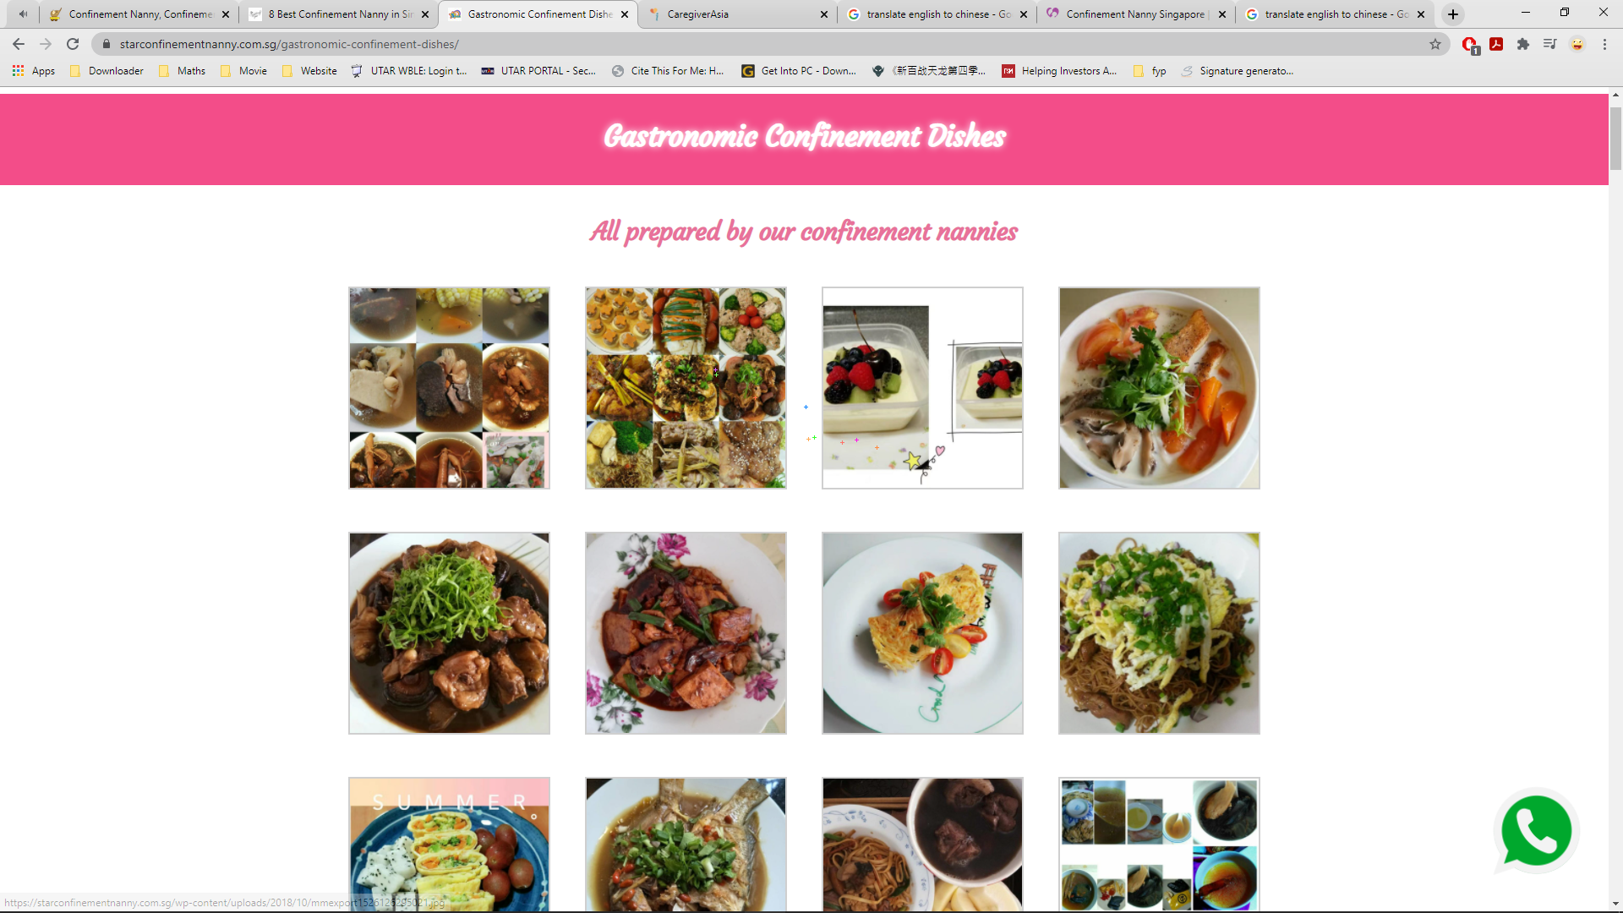

***Figure 2.2.4.2.2 Confinement Dishes of Star Confinement Nanny.***

**2.2.4.3 Weaknesses and Limitations**

However, Star Confinement Nanny does not provide e-commerce platform for the seller to sell the item on their website. The location provided by the agency is written by word form instead of displaying the location via graphical view.

**2.2.4.4 Suggestions and Recommendations**

Star Confinement Nanny could ask their IT team to setup a platform on their site to let the intention seller to sell their product on the platform. Next, the IT team could also implement the Google API in the webpage to show out the location of the Star Confinement Nanny on their page.

### 2.2.5 PEM Confinement Nanny Agency

**2.2.5.1 Description**

PEM Confinement Nanny Agency was established in 1987 and has been in the industry for 30 years. PEM Confinement Nanny Agency is the largest Confinement Centre in Singapore with over 400 nannies and is the first confinement nanny agency to be licensed by Ministry of Manpower (MOM) (PEM Confinement Nanny Agency, 2021). PEM Confinement Nanny Agency provide the following services which is baby care, laundry work for mother and baby, confinement bath, confinement herbal tonics, confinement food, domestic chores, guidance for mother in breastfeeding and advices in an affordable price.

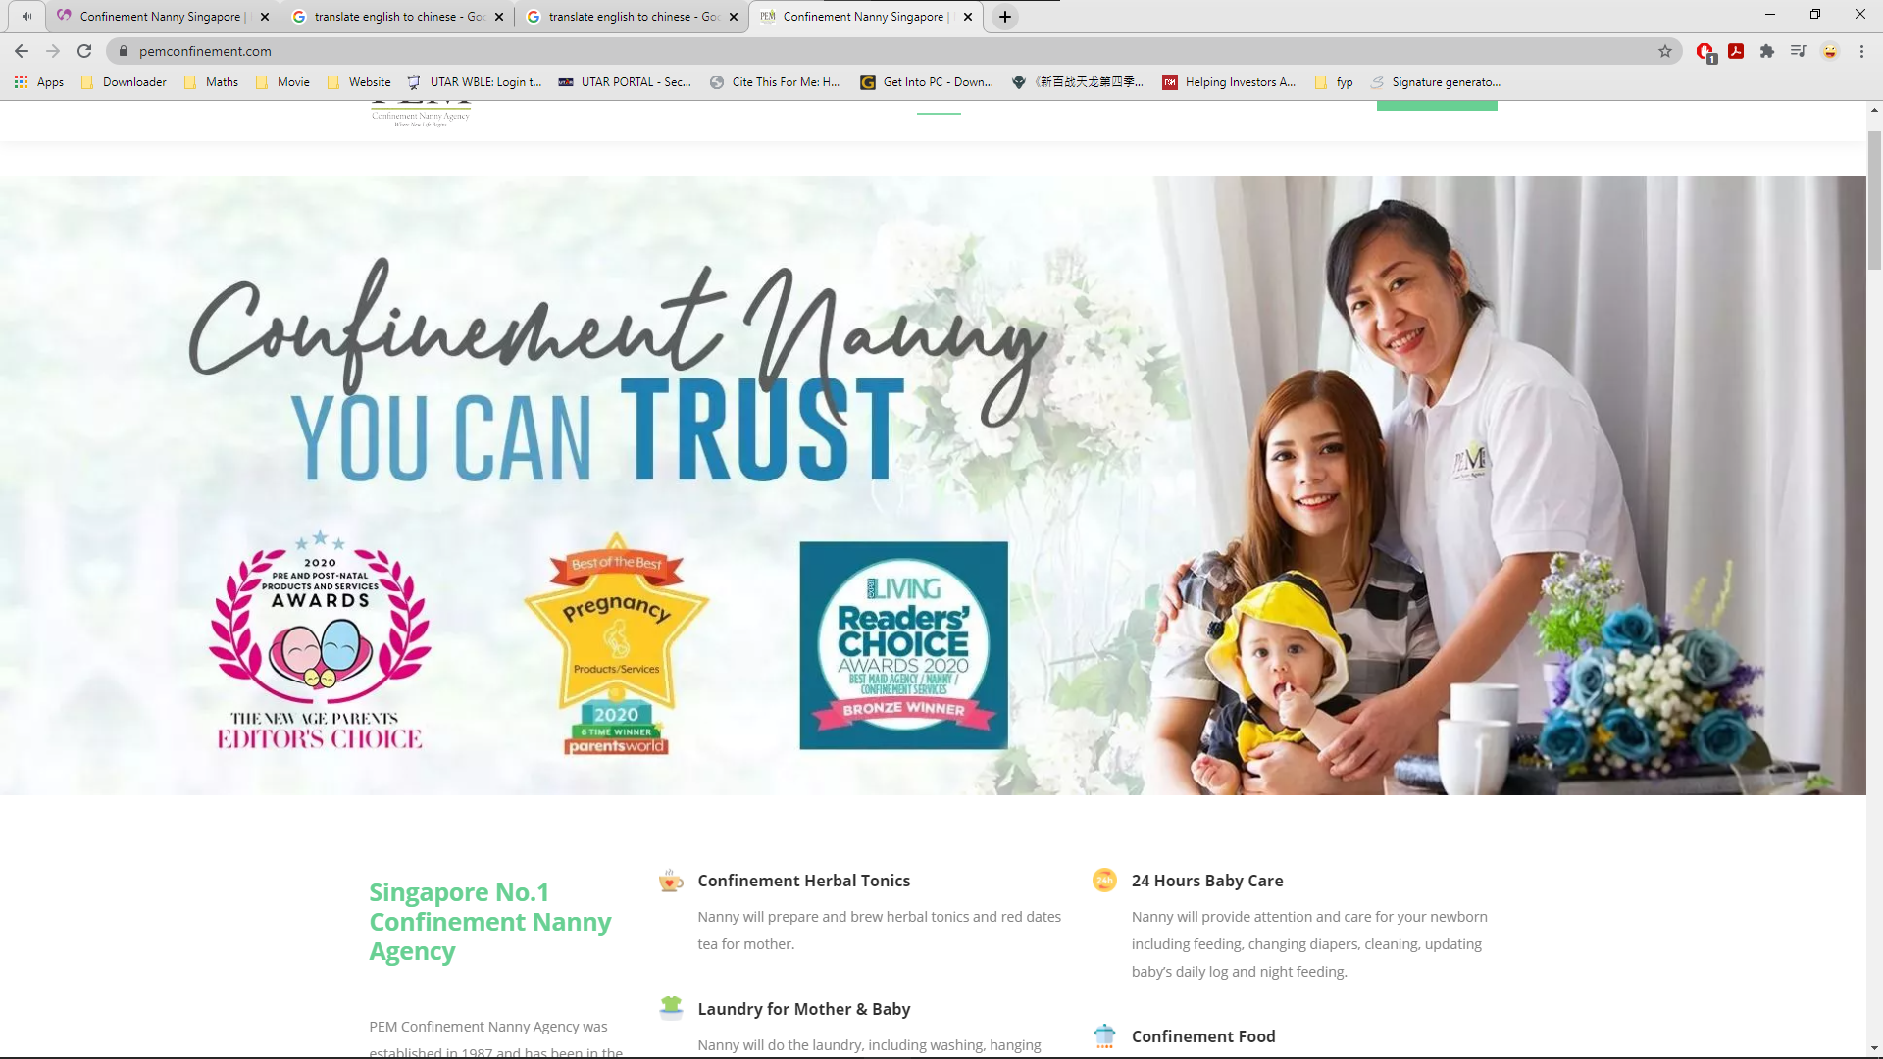

***Figure 2.2.5.1.1 Main Interface of PEM Confinement Nanny Agency***

**2.2.5.2 Strengths**

PEM Confinement Nanny Agency had listed out all of its services in graphical way at the main interface which make its interface more attractive. Besides, PEM Confinement Nanny Agency display its rating and review from customers in a more interesting method which is swiper slide to attract the attention of the customers while visiting the webpage.

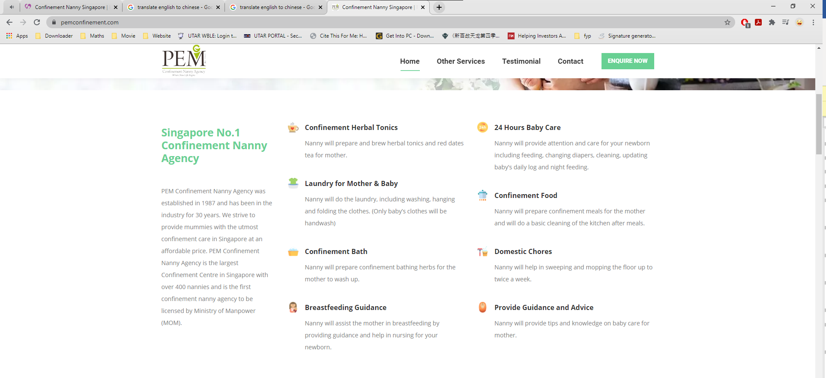

***Figure 2.2.5.2.1 Services listed in Graphical View.***

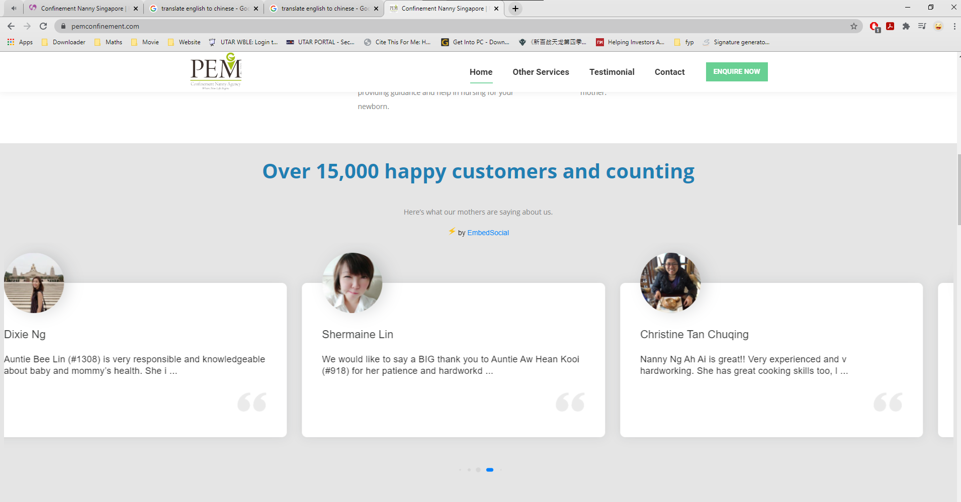

***Figure 2.2.5.2.2 Review from Customers of PEM Confinement Nanny Agency.***

**2.2.5.3 Weaknesses and Limitations**

First of all, PEM Confinement Nanny Agency does not have the live chat system which make a lot of trouble to customer who wish to get some consultation from PEM Confinement Nanny Agency. Next, customers cannot make reservation with PEM Confinement Nanny Agency through calendar which might make both sides could not came out an appropriate time to meet each other. Lastly, the location of PEM Confinement Nanny Agency had been stated unclearly since it did not provide a detail address which might cause the customer unable to find confinement center.

**2.2.5.4 Suggestions and Recommendations**

PEM Confinement Nanny Agency could implement a chat API into the system for the staff to contact with the customers. Next, PEM Confinement Nanny Agency can set up the reservation system with associated with calendar system so that the customer can reserve an available time for themselves. PEM Confinement Nanny Agency could implement Google Maps API into the webpage to show the location of the confinement center for the customers to have a more detail graphical location view.

### 2.2.6 Comparison between the similar application with the proposal system

The following table show the comparison between the similar application with the proposed system:

|  |  |  |  |  |  |  |
| --- | --- | --- | --- | --- | --- | --- |
| Features | 28days(website) | Confinement Care Malaysia PLT (website) | NannySOS | Star Confinement Nanny | PEM Confinement Nanny Agency | Proposed system |
| Rating system | Close with solid fill | Close with solid fill |  | Close with solid fill | Close with solid fill | Checkmark with solid fill |
| Customizable service package | Close with solid fill | Close with solid fill | Close with solid fill | Checkmark with solid fill | Close with solid fill | Checkmark with solid fill |
| Nearby Tracking System | Close with solid fill | Close with solid fill | Close with solid fill | Close with solid fill | Close with solid fill | Checkmark with solid fill |
| GPS navigation | Close with solid fill | Close with solid fill | Close with solid fill | Close with solid fill | Close with solid fill | Checkmark with solid fill |
| Notification alert | Close with solid fill | Close with solid fill | Close with solid fill | Close with solid fill | Close with solid fill | Close with solid fill |

***Table 2.2.6.1 Table of Comparison Between Reviewed System and Proposed System***

## 2.3 Discussion

From the Table 2.2.6.1, the author has chosen few features to compare with the existing web application. First of all, is the rating system. The table show that most of the application in the market does not have the rating system to visualize the quality of the confinement service provided by the confinement lady. The confinement lady might not give as much effort as they can to provide the confinement service if there is no any system that can monitor or rate their service which might cause the reputation of the agency become worse.

Besides, the customizable service package is chosen to be implement into system. The reason for choose this feature is the author would like to provide the Mothers have more selection of the choice during the confinement service selection stage compared to other web application in the market which only allow user to choose for the confinement service package that they provided. However, users might only need some part of the confinement service in the package which will cause the user extra spend the money for the service that no necessary. Besides, confinement ladies also able to customize their own unique confinement service package for sale to attract more customer.

Navigation system is chosen to apply in this module to navigate the confinement lady to reach the Mother’s house and avoid unnecessary time wastage by the confinement lady during travel to the Mother’s house.

The GPS tracking system will be added into the system also to allow Mothers look for the confinement ladies that stay near around them. The main reason to add this feature into the system is because this can allow Mothers to find the confinement lady that stay near them so that the food or beverages prepared by the confinement lady able to suit the Mother’s taste.

In Table 2.1.5.1, it shows that the comparison between Haversine algorithm and Vincenty algorithm. Haversine algorithm have a faster computation time and a lower brain consumption compared to the Vincenty algorithm. However, the Vincenty algorithm have a higher accuracy of the result compared to Haversine. For this application, the distance computed between two users does not need a high precision on the result. Therefore, the Haversine algorithm is applied in this case due to the computation time and brain consumption is better than Vincenty algorithm.

# System Methodology/Approach

The Agile software development methodology was applied in the development process for this project. The purpose to choose this method for this project is that it able to develop software that is both high quality and low-cost.

At the brainstorm a.k.a. planning stage, the developer will analysis the problems faced by the users and came out the solutions based on the requirement of the users. Then, in the design stage, developer will design the framework of the system, design the documents needed, prototype of the application, and the function and algorithm that need to be implemented into the system. At the development stage, the function and algorithm will be implemented into the system by developer one by one until the expected output is achieved. The developer will test the system again and again in the quality assure stage a.k.a. testing stage to identify and solve the potential bug in the system. If all of the functionally of the system is develop completely, the system will be delivered to the users. Otherwise, the developers will continue to fix the system until it error-free.

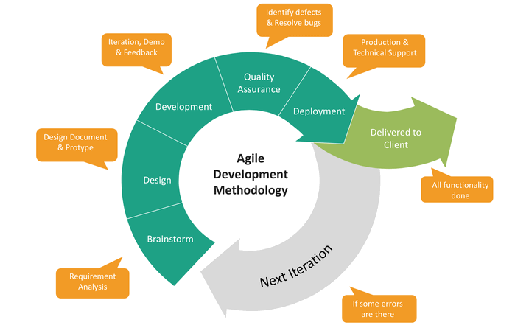

***Figure 3.1 Agile Software Development Phases***

## 3.1 System Design Diagram/Equation

### 3.1.1 System Architecture Diagram

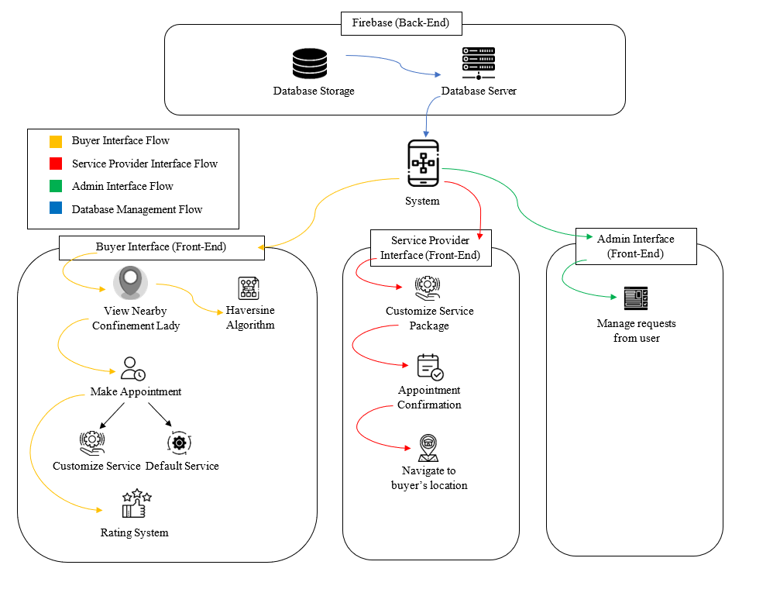

***Figure 3.1.1.1 System Architecture Diagram of E-confinement Service System***

This is the system architecture diagram of the e-confinement service system. The system is split into two part which is front-end and back-end. There are 4 different flow in this system architecture diagram which is buyer interface flow, service provider interface, admin interface flow, database management flow. Each flow is represented by their own unique color.

#### 3.1.1.1 Buyer Interface Flow

Buyer interface flow starts when the buyer login the user log into their account. Haversine algorithm will start computing the distance between the buyer and the service provider a.k.a. confinement lady. The nearer confinement lady will be displayed first followed by the further as a list at the homepage of the buyer. Buyer can start make order after they choose the confinement lady. Buyer can either select the provided package by the confinement lady or customize the service package based on the provided package. After make the order with the confinement lady, the buyer needs to wait for the confirmation from the confinement lady. At the end of the service, buyer can rate the performance of the confinement lady.

#### 3.1.1.2 Service Provider Interface Flow

Service provider interface flow starts when the service provider a.k.a. confinement lady log into their account. Confinement lady can start to set up their confinement service package. There are 3 different type of packages to let the confinement lady customize the service that they want to include into the package. Besides, after they confirm the order made by the buyer, they can press the navigation button to navigate to the buyer’s house.

#### 3.1.1.3 Admin Interface Flow

Admin interface flow starts when there is cancel order request raised by the buyer. Admin need to manage the requests raised by the buyer by approve or decline the request based on their reason.

#### 3.1.1.4 Database Management Flow

Database management flow starts when the user registers an account in the system. The users must use their email to register an account and provide all the required information to be stored in the database. The service information provided by the service provider will be stored in the database. Moreover, the order details made by the users will also be stored in the database for the order tracing in the future. The location of the users also will be stored in the database to be used as parameter to compute the distance between the buyer and confinement lady. In addition, the rating review given by the buyer will also store in the database to be displayed as an information for the service provider. All the data will be stored in the Firebase so that the data can be tracked in the future.

### 3.1.2 Use Case Diagram and Description

A use case is a written description of how the users will interact and perform tasks in the system. In this section, there had two sub-section which is use case diagram and use case description. Use case diagram summarize the relationship between the use cases, actors and the system. Besides, the use case description also described the sequences of the users from beginning until ending to achieve the goal.

#### 3.1.2.1 Use Case Diagram

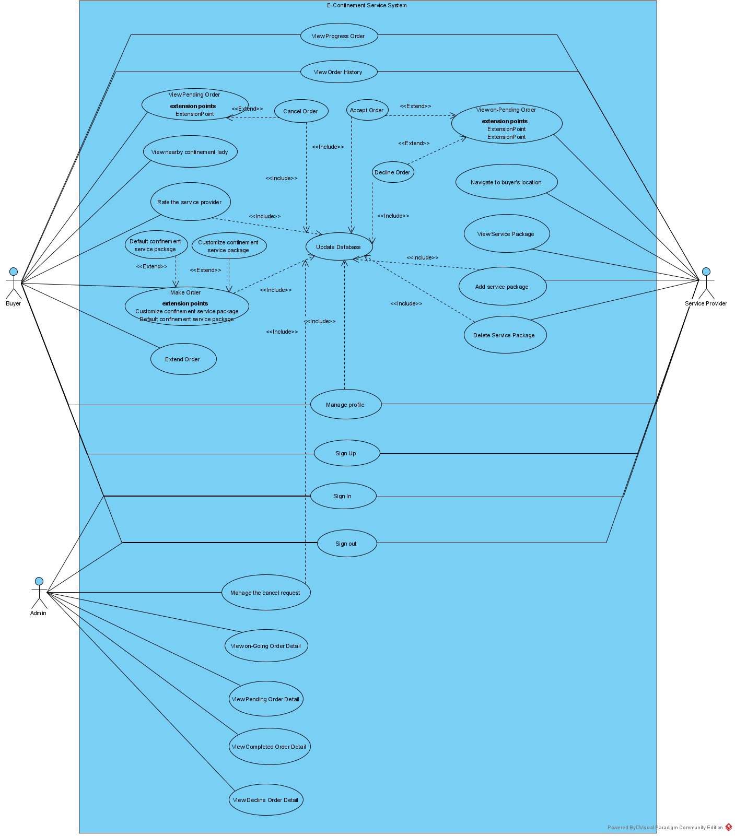

***Figure 3.1.2.1.1 Use Case Diagram***

Figure 3.1.2.1.1 has shown the use case diagram of the e-confinement service system. There are three type of user in the system which is buyer, service provider and admin. Buyer and service provider able to sign up, sign in, and sign out in the application. They also able to manage their profile by editing the name, phone number, address and other personal information. Admin only able sign into the account for administration purpose.

Admin user only able to be assigned at the backend by the administrator. Admin able to view all the order information that made between the buyer and service provider. They also able to manage the cancel order request raised by the buyer.

For buyer, they are able to view the nearby service provider a.k.a. confinement lady from the nearest to the furthest as a list at the home page. After select the confinement lady, they are able to make the order offered by the confinement lady. If they wish to remove some of the service offered by the confinement lady, they also able to remove the particular service. Buyer also able to cancel the order request and refund the money before the confinement lady confirm the order at the pending order page. Buyer also able to check the progress order detail at the progress order page. Buyer can choose to extend the date of confinement service if they wish to extend the confinement service after discuss with the confinement lady. After all the services ended, buyer able to rate their confinement lady, by providing the photo, videos and comment about their experience at the page provided. All the rating detail and the order detail will be updated to the database. Buyer also able to view their order history to see their previous order detail.

Next, service provider able to add and delete their own service package. Service provider also able to view the service packages added by them. Besides, service provider able to view all the order detail that make with them. They can choose either to accept or to decline the order. If decline the order, the system will remove the order. Once accept the order, the system will add the order detail at the progress order page as a further reference for service provider. Service provider can navigate to the buyer house by using the google map with click the button provided in the order detail page.

#### 3.1.2.2 Use Case Description

##### 3.1.2.2.1 Sign Up

|  |  |  |
| --- | --- | --- |
| Use case name: Sign up | ID: 001 | Important level: High |
| Primary Actor: Buyer, Service Provider | | |
| Stakeholders and Interests:  Buyer, Service Provider – want to sign up a user account to access the system. | | |
| Trigger: User wants to sign up as a customer. | | |
| Normal Flow of Events:   1. User fill the email and password in the provided column. 2. User click the “Sign Up” button. 3. System will authenticate the information of user. 4. System will direct the user to Personal Detail page. 5. User fill up the profile information. 6. User click the “Complete” button. 7. System will show Terms & Condition for the user. 8. User click “Agree” to proceed. 9. System will save the data into database. 10. System will direct user to their main page. 11. System display “Successfully Sign Up” message to user. | | |
| Sub Flows:  S-2.1 If email or password is not complete, system will display the error message.  S-3.1 If the email of the customer duplicate with the database, system will ask customer to retype a new email.  S-6.1 If the profile information is not complete, system will toast the message for the user.  S-8.1 If user did not agree the Terms & Condition, system will stop at the profile information filling stage. | | |

***Table 3.4.3.1 Sign Up Use Case Description***

### 3.4.3 Use Case Description

#### 3.4.3.1 Sign up Module (Customer)

|  |  |  |
| --- | --- | --- |
| Use case name: Sign up | ID: 003 | Important level: High |
| Primary Actor: Customers | Use Case Type: Detail, Essential | |
| Stakeholders and Interests:  Customers – want to sign up a user account to access the system. | | |
| Brief Description: This use case describes the process of customer sign up for a user account. | | |
| Trigger: User wants to sign up as a customer. | | |
| Association: Customer | | |
| Normal Flow of Events:   1. Customer fill the email and password in the provided column. 2. Customer fill the personal details in the registration form. 3. Customer select the user type as a role. 4. Customer submit the registration form with the submit button. 5. System validate the email with database. 6. System save the information of customer. 7. System display “Successfully Sign Up” message to customer. | | |
| Sub Flows:  S-1. If the email of the customer duplicate with the database, system will ask customer to retype a new email. | | |

***Table 3.4.3.1 Use Case description for Customer Sign Up Module***

#### 3.4.3.2 Sign in Module (Customer)

|  |  |  |
| --- | --- | --- |
| Use case name: Sign in | ID: 002 | Important level: High |
| Primary Actor: Customer | Use Case Type: Detail, Essential | |
| Stakeholders and Interests:  Customer – want to sign in account to access the e-confinement service system. | | |
| Brief Description: This use case describes the process of customer login to the e-confinement service system. | | |
| Trigger: User wants to sign in as a customer. | | |
| Association: Customer | | |
| Normal Flow of Events:   1. Customer enter the email and password at the provided space. 2. Customer submit the sign in request. 3. System validate the email and password. 4. System display “Login Successful” message to customer. 5. Customer will be directed to the customer user interface. | | |
| Sub Flows:  S-1. If validation is failed, system display error message to customers.  S-2. If customer forget password, customers can request system to change password. | | |

***Table 3.4.3.2 Use Case description for Customer Sign in Module***

#### 3.4.3.3 Select Confinement Service Module

|  |  |  |
| --- | --- | --- |
| Use case name: Select Confinement Service | ID: 004 | Important level: High |
| Primary Actor: Customer | Use Case Type: Detail, Essential | |
| Stakeholders and Interests:  Customer – want to choose the confinement service packages. | | |
| Brief Description: This use case describes the process of selecting confinement service package from application. | | |
| Trigger: Customer want to choose confinement service packages. | | |
| Association: Customer  Extend: Choose default confinement service package, Customize confinement service package | | |
| Normal Flow of Events:   1. Customer click the Order Now button. 2. System direct customer to the service page. 3. Customer select the service, confinement lady and the confinement date. 4. Customer click the checkout button. 5. System send the confinement service request to the selected confinement lady. | | |
| Sub Flows:  - | | |

***Table 3.4.3.3 Use Case description for Select Confinement Service Module***

|  |  |  |
| --- | --- | --- |
| Use case name: Choose default Confinement Service Package | ID: 005 | Important level: High |
| Primary Actor: Customer | Use Case Type: Detail, Essential | |
| Stakeholders and Interests:  Customer – want to choose the default confinement service packages. | | |
| Brief Description: This use case describes the process of customer choosing default confinement service package. | | |
| Trigger: Customer wants to choose default confinement service package. | | |
| Association: Customer | | |
| Normal Flow of Events:   1. Customer choose the default confinement service package button on the confinement service selection page. 2. System display the list of default package. 3. Customer select the default confinement service package. 4. Customer click “Proceed” button to confirm the order. 5. System save the order detail. 6. System display message “Service added” to customer. | | |

***Table 3.4.3.4 Use Case description for Choose Default Confinement Service Package module***

|  |  |  |
| --- | --- | --- |
| Use case name: Customize Confinement Service Package | ID: 006 | Important level: High |
| Primary Actor: Customer | Use Case Type: Detail, Essential | |
| Stakeholders and Interests:  Customer – want to customize the confinement service packages. | | |
| Brief Description: This use case describes the process of customer customize his own confinement service package. | | |
| Trigger: Customer want to the customize confinement service package. | | |
| Association: Customer | | |
| Normal Flow of Events: s   1. Customer choose the customize confinement service package button on the confinement service selection page. 2. System display the list of available confinement service. 3. Customer add the confinement service that he wanted into package. 4. Repeat step 1 until he added all the confinement service that he wanted. 5. Customer click “Proceed” button to confirm the order. 6. System validate the order package has more than 3 confinement services. 7. System save the order detail. 8. System display message “Service added” to customer. | | |
| Sub Flows:  S-1. If customer select less than 3 confinement service, system display message “Need more than 3 confinement service to be added into package” and return to the customize confinement service selection page. | | |

***Table 3.4.3.5 Use Case description for Customize Confinement Service Package***

#### 3.4.3.4 View Order Summary Module

|  |  |  |
| --- | --- | --- |
| Use case name: View Order Summary | ID: 008 | Important level: Medium |
| Primary Actor: Customers | Use Case Type: Detail, Essential | |
| Stakeholders and Interests:  Customers – want to check the order they made. | | |
| Brief Description: This use case describes the process of customer to check the order. | | |
| Trigger: Customer wants to check the order. | | |
| Association: Customer | | |
| Normal Flow of Events:   1. Customer click the “Orders” button. 2. System validate the order of the customer. 3. System display the order to the customer. | | |
| Sub Flows:  S-1. If customer did not place any order previously, the system will display “No order has been made.” message. | | |

***Table 3.4.3.6 Use Case description for View Order Summary Module***

#### 3.4.3.5 Rate Confinement Lady Module

|  |  |  |
| --- | --- | --- |
| Use case name: Rate confinement lady | ID: 009 | Important level: High |
| Primary Actor: Customers | Use Case Type: Detail, Essential | |
| Stakeholders and Interests:  Customers – want to rate the confinement lady services. | | |
| Brief Description: This use case describes the process of customer rating the confinement service. | | |
| Trigger: Customer wants to rate the confinement service. | | |
| Association: Customer | | |
| Normal Flow of Events:   1. Customer click the “Complete Order” button below the Order Summary. 2. System display the rating star system and description for the customer. 3. Customer enter the experiences of the confinement service and choose the number of stars given to that particular confinement lady. 4. Customer submit the rating request. 5. System display submit successful message. | | |
| Sub Flows:  - | | |

***Table 3.4.3.7 Use Case description for Rate Confinement Lady Module***

#### 3.4.3.6 Report Problem Module

|  |  |  |
| --- | --- | --- |
| Use case name: Report problem | ID: 010 | Important level: Low |
| Primary Actor: Customers | Use Case Type: Detail, Essential | |
| Stakeholders and Interests:  Customers – want to report the problem faced when using the application. | | |
| Brief Description: This use case describes the process of customer reporting their problem faced when using the application. | | |
| Trigger: Customer wants to report the problem faced when using the application. | | |
| Association: Customer | | |
| Normal Flow of Events:   1. Customer click the “Report Bug” button. 2. System directed customers to the Report Page. 3. Customer enter the problems faced and email address at the provided space. 4. Customer click the “Submit” button. | | |
| Sub Flows:  - | | |

***Table 3.4.3.8 Use Case description for Report Problem Module***

#### 3.4.3.7 Sign Up Module (Confinement Lady)

|  |  |  |
| --- | --- | --- |
| Use case name: Sign up | ID: 011 | Important level: High |
| Primary Actor: Confinement Lady | Use Case Type: Detail, Essential | |
| Stakeholders and Interests:  Confinement Lady – want to sign up a user account to access the system. | | |
| Brief Description: This use case describes the process of confinement lady sign up for a user account. | | |
| Trigger: User wants to sign up as confinement lady. | | |
| Association: Confinement lady | | |
| Normal Flow of Events:   1. Confinement lady fill the email and password in the provided column. 2. Confinement lady fill the personal details in the registration form. 3. Confinement lady submit the registration form with the submit button. 4. System validate the email with database. 5. System save the information of confinement lady. 6. System display “Successfully Sign Up” message to confinement lady. | | |
| Sub Flows:  S-1. If the email of the confinement lady duplicate with the database, system will ask customer to retype a new email. | | |

***Table 3.4.3.9 Use Case description for Confinement Lady Sign Up Module***

#### 3.4.3.8 Sign in Module (Confinement Lady)

|  |  |  |
| --- | --- | --- |
| Use case name: Sign in | ID: 012 | Important level: High |
| Primary Actor: Confinement Lady | Use Case Type: Detail, Essential | |
| Stakeholders and Interests:  Confinement Lady – want to sign in account to access the e-confinement service system. | | |
| Brief Description: This use case describes the process of confinement lady login to the e-confinement service system. | | |
| Trigger: User wants to sign in as a confinement lady. | | |
| Association: Confinement lady | | |
| Normal Flow of Events:   1. Confinement lady enter the email and password at the provided space. 2. Confinement lady submit the sign in request. 3. System validate the email and password. 4. System display “Login Successful” message to confinement lady. 5. Confinement lady will be directed to the confinement lady user interface. | | |
| Sub Flows:  S-1. If validation is failed, system display “error” to confinement lady.  S-2. If confinement lady forget password, confinement lady can request system to change password. | | |

***Table 3.4.3.10 Use Case description for Confinement Lady Sign in Module***

#### 3.4.3.9 View Rating Module

|  |  |  |
| --- | --- | --- |
| Use case name: View Rating | ID: 013 | Important level: Medium |
| Primary Actor: Confinement lady | Use Case Type: Detail, Essential | |
| Stakeholders and Interests:  Customers – want to view the rating from the customers. | | |
| Brief Description: This use case describes the process of confinement lady view the rating from customers. | | |
| Trigger: Confinement lady wants to view the rating from customers. | | |
| Association: Confinement lady | | |
| Normal Flow of Events:   1. Confinement lady click their profile page. 2. System display profile page to confinement lady. 3. System display the current rating star of confinement lady obtained. 4. Confinement lady click view detail button. 5. System display the list of description of the rating made by the customers. | | |
| Sub Flows:  - | | |

***Table 3.4.3.11 Use Case description for View Rating Module***

#### 3.4.3.10 Navigation Module

|  |  |  |
| --- | --- | --- |
| Use case name: Navigate to Customer’s house | ID: 013 | Important level: High |
| Primary Actor: Confinement lady | Use Case Type: Detail, Essential | |
| Stakeholders and Interests:  Customers – want to navigate to customer’s house | | |
| Brief Description: This use case describes the process of confinement lady navigate to the customer’s house. | | |
| Trigger: Confinement lady wants to navigate to the customer’s house. | | |
| Association: Confinement lady | | |
| Normal Flow of Events:   1. Confinement lady click the progressing order. 2. System display the detail of the order to the confinement lady. 3. Confinement lady click the navigation button beside the customer’s address. 4. The system will retrieve the geolocation of the confinement lady and the customer. 5. System will generate the route and direct the user to the Google Maps page. 6. System will display the route on the map. 7. The system will navigate the route for the confinement lady to reach the customer’s house. | | |
| Sub Flows:  - | | |

***Table 3.4.3.12 Use Case description for Navigate to Customer’s house***

### 3.4.4 Activity Diagram

#### 3.4.4.1 Sign Up Module (Customer)

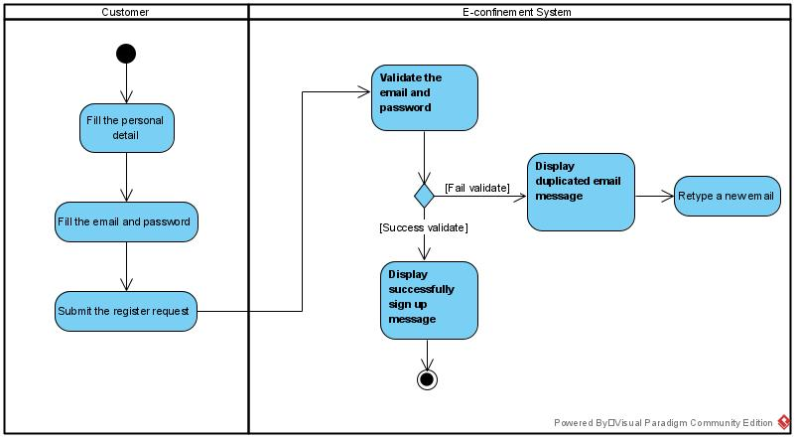

***Figure 3.4.4.1 Activity Diagram for Sign Up Module***

#### 3.4.4.2 Sign In Module (Customer)

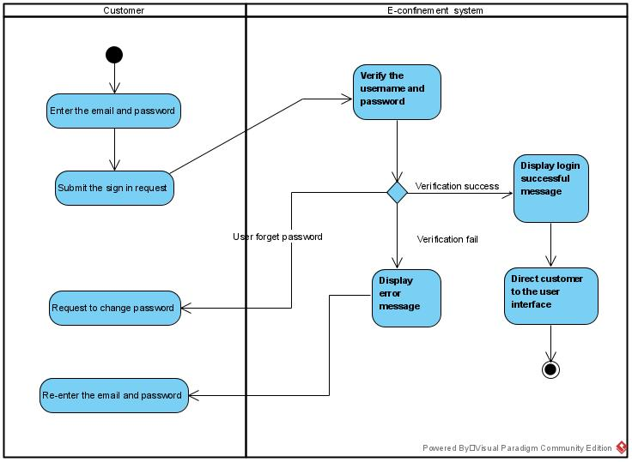

***Figure 3.4.4.2 Activity Diagram for Sign in Module***

#### 3.4.4.3 Select Confinement Service Module

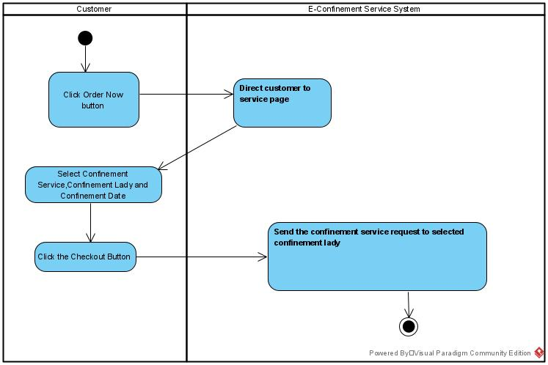

***Figure 3.4.4.3 Activity Diagram for Select Confinement Service Module***

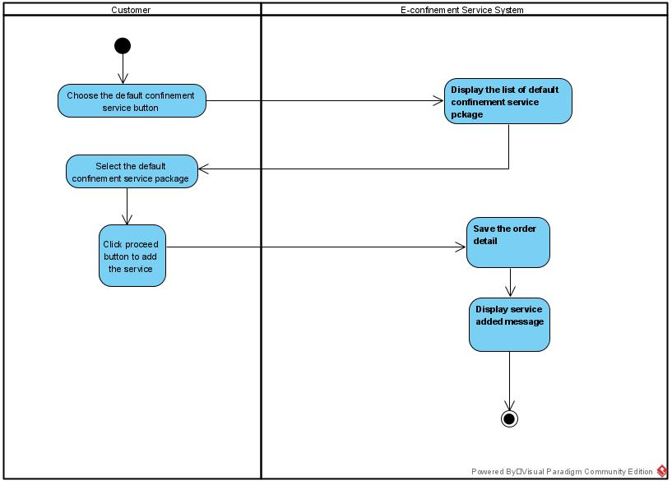

***Figure 3.4.4.4 Activity Diagram for Select Default Confinement Service Package Module***

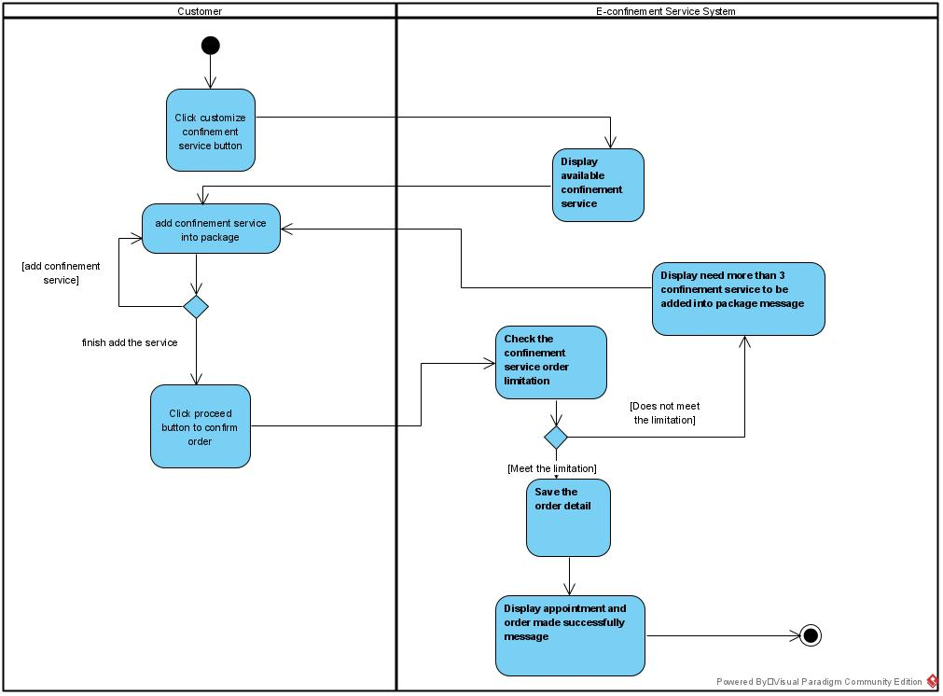

***Figure 3.4.4.5 Activity Diagram for Select Customize Confinement Service Package Module***

#### 3.4.4.4 View Order Summary Module

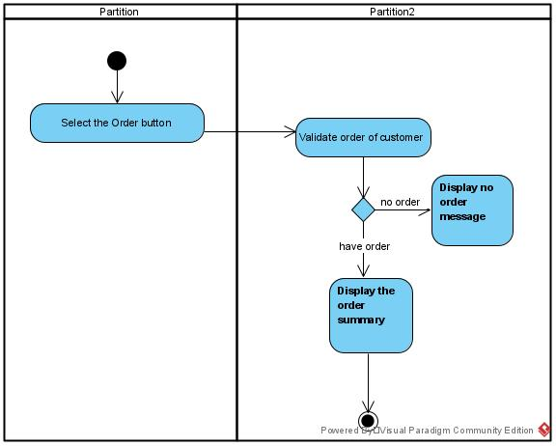

***Figure 3.4.4.6 Activity Diagram for View Order Summary Module***

#### 3.4.4.5 Rate Confinement Lady Module

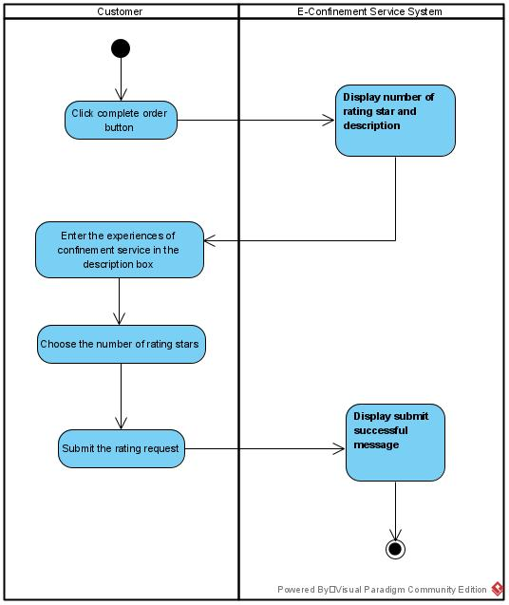

***Figure 3.4.4.7 Activity Diagram for Rate Confinement Lady Module***

#### 3.4.4.6 Report Problem Module

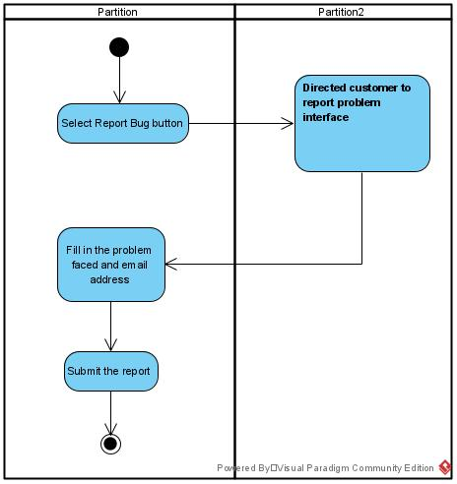

***Figure 3.4.4.8 Activity Diagram for Report Problem Module***

#### 3.4.4.7 Sign up Module (Confinement Lady)

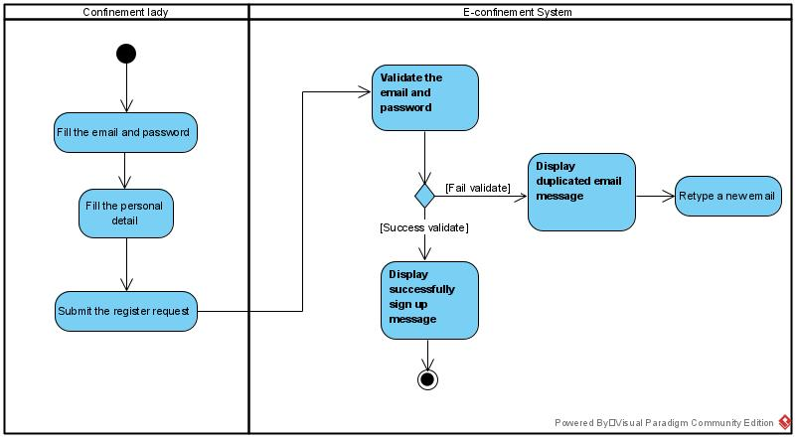

***Figure 3.4.4.9 Activity Diagram for Confinement Lady Sign Up Module***

#### 3.4.4.8 Sign in Module (Confinement Lady)

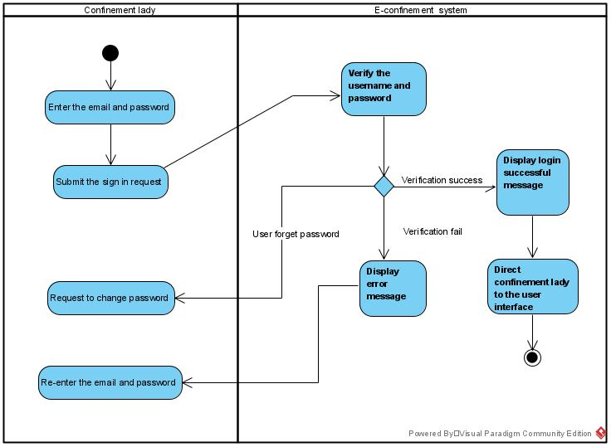

***Figure 3.4.4.10 Activity Diagram for Confinement Lady Sign in Module***

#### 3.4.4.9 Navigation Module

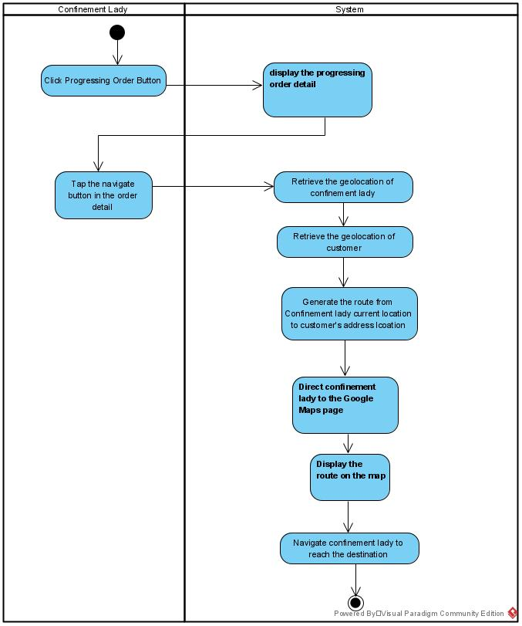

***Figure 3.4.4.11 Activity Diagram for Navigate to Customer’s House***

#### 3.4.4.10 View Rating Module

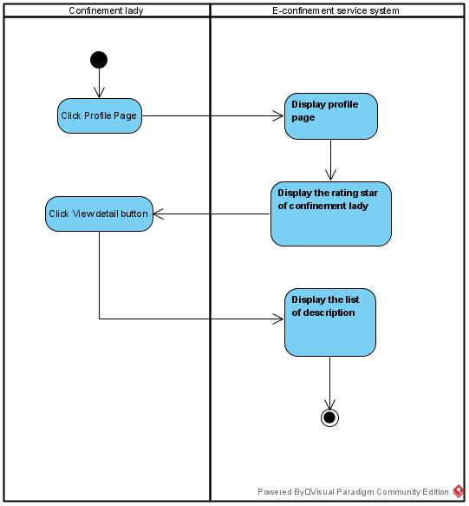

***Figure 3.4.4.12 Activity Diagram for View Rating Module***

### 3.4.5 Sequence Diagram

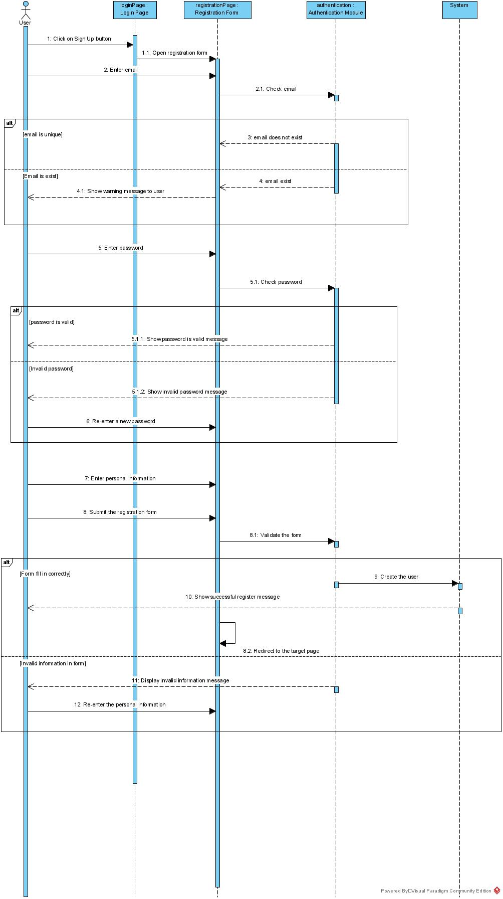

***Figure 3.4.5.1 Sequence Diagram for Sign Up Module***

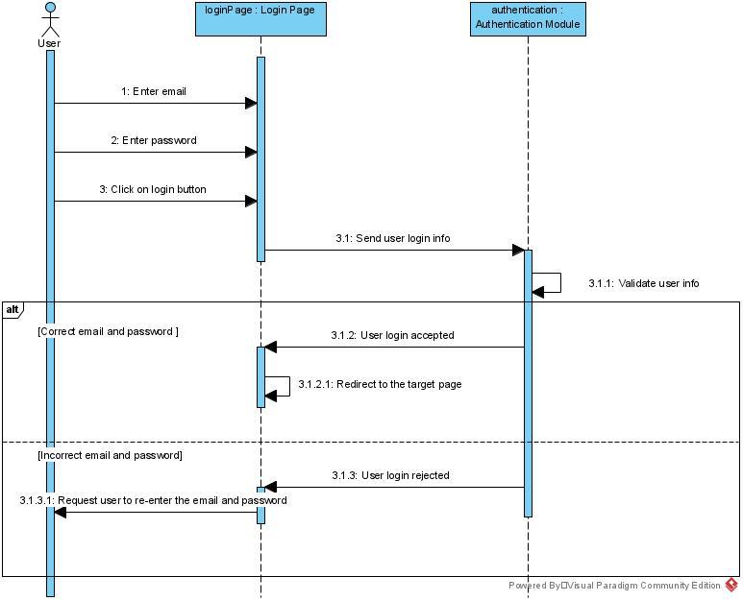

***Figure 3.4.5.2 Sequence Diagram for Sign in Module***

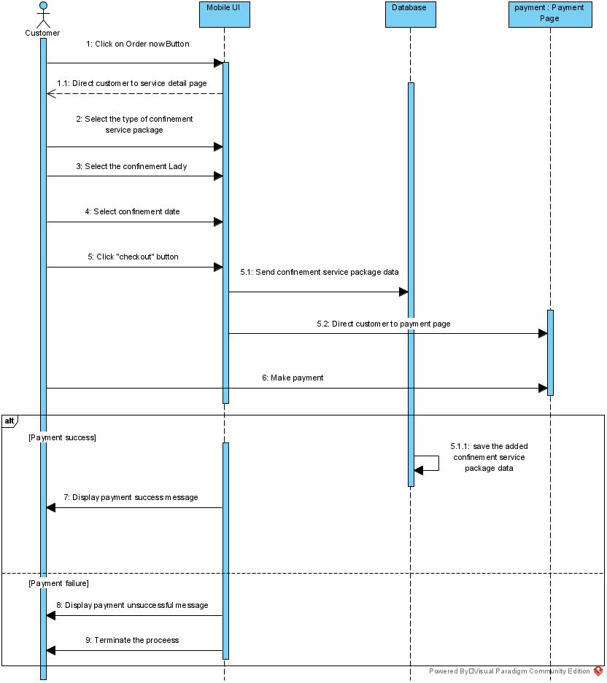

***Figure 3.4.5.3 Sequence Diagram for Select Confinement Service Module***

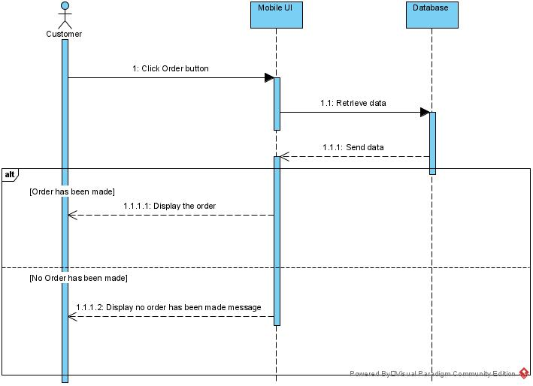

***Figure 3.4.5.4 Sequence Diagram for View Order Summary Module***

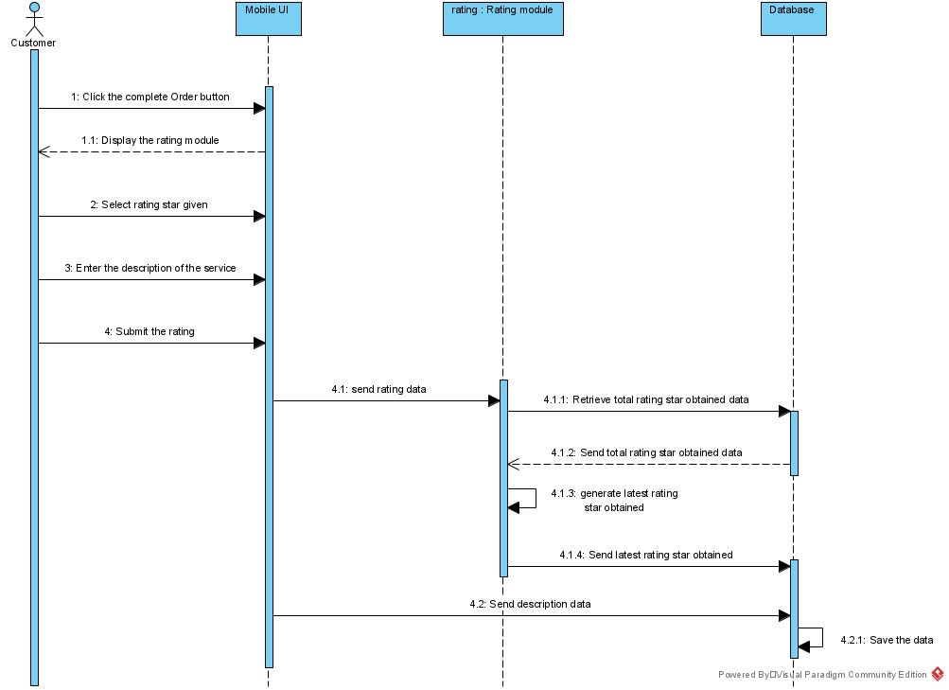

***Figure 3.4.5.5 Sequence Diagram for Rating Confinement Lady Module***

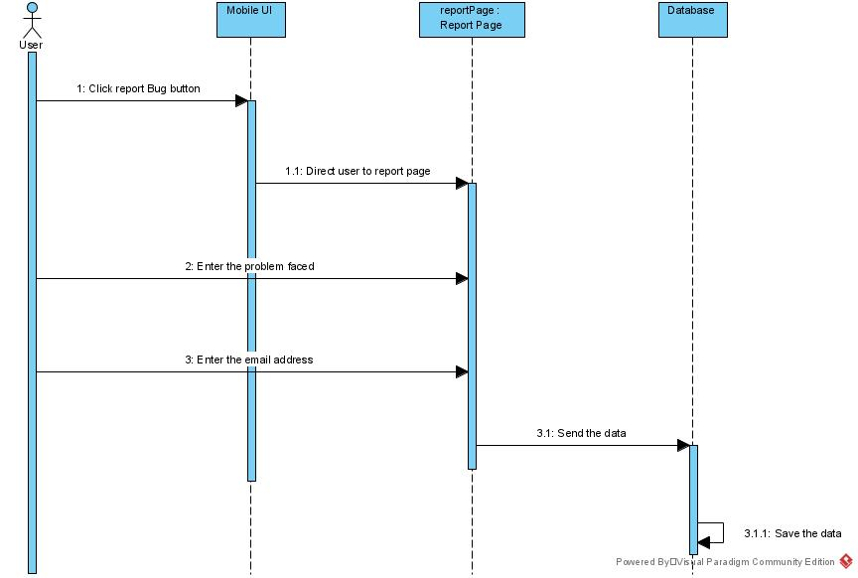

***Figure 3.4.5.6 Sequence Diagram for Report Problem Module***

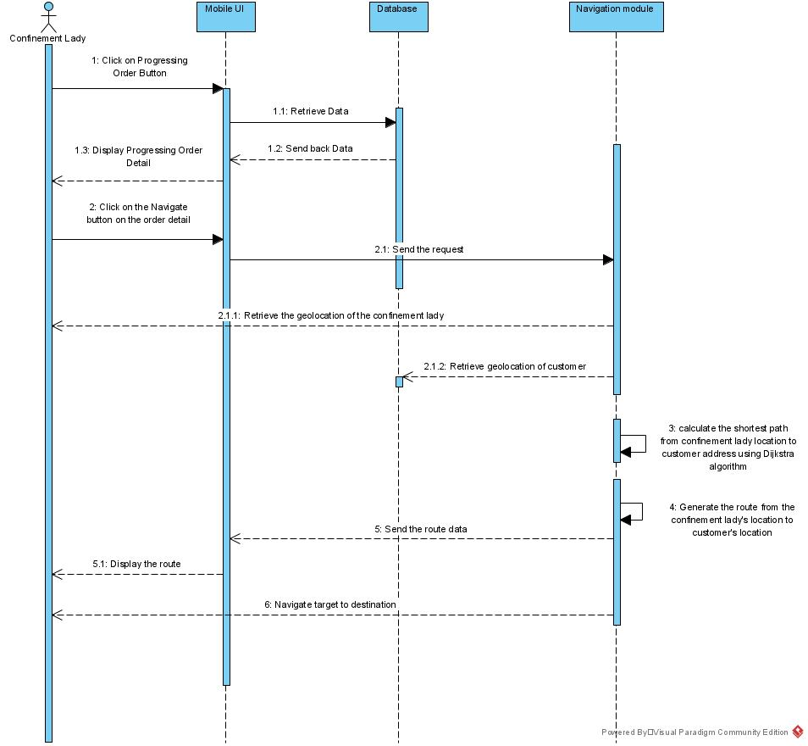

***Figure 3.4.5.7 Sequence Diagram for Navigate to Customer House module***

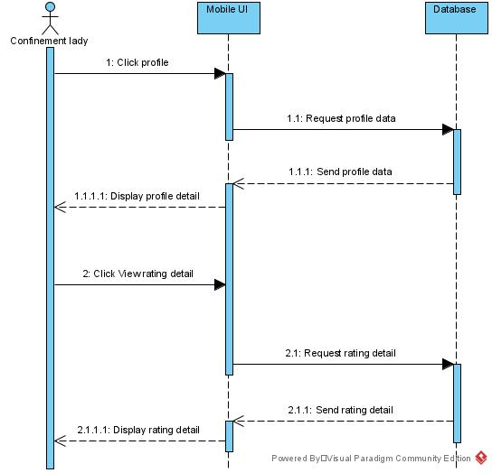

***Figure 3.4.5.8 Sequence Diagram for View Rating Module***

## 3.5 Verification Plan

Verification plans are needed to ensure the accuracy, consistency and performance of the system.

1. Verification when user login their account

Users will key in their email and password when login in the system based on their account. The system will validate the email and password. The system will display errors when users key in their email and password wrongly.

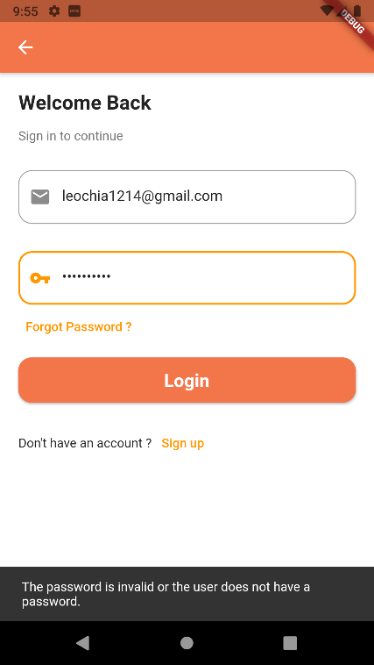

***Figure 3.5.1 Login Verification***

1. Verification when user register their account

Users will register themselves if they are new users. Users will input their information such as name, phone number, email and password. The system will validate the users’ information. The system will display an “account exist” message when it detects there is the same account in the system.

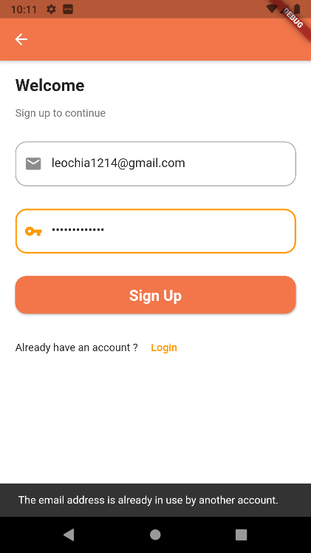

***Figure 3.5.2 Sign Up Verification***

1. Verification when users key in their password.

Users will input the password and the password must have more than 8 characters when they sign in/register their account.

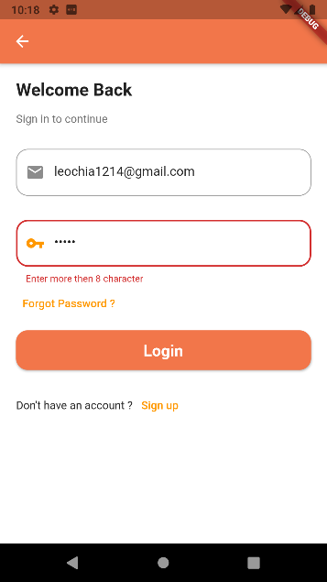 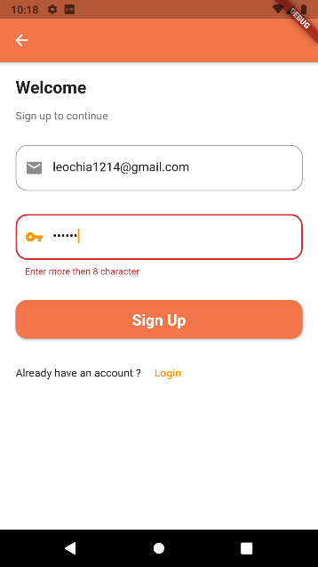

***Figure 3.5.3 Password Verification in Sign in and Sign Up***

1. Verification when users key in their email.

Users will key in the email and the system will verified whether it is a valid email.

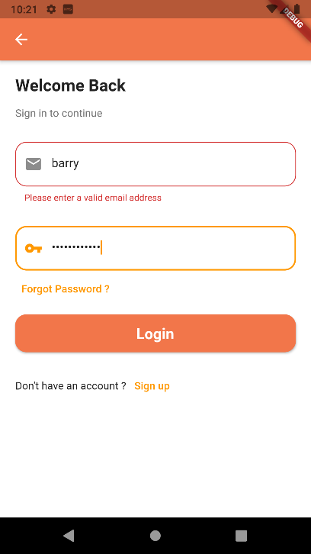 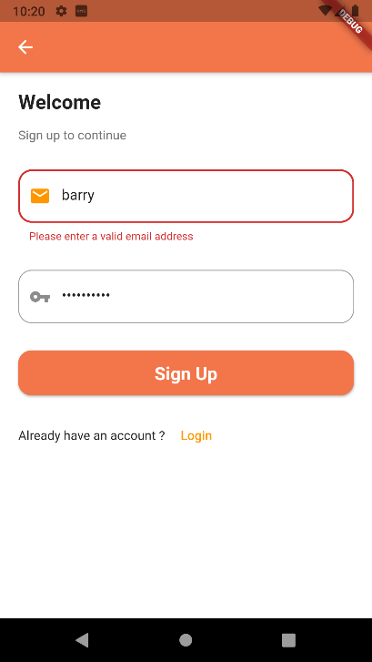

***Figure 3.5.4 Email Verification in Sign in and Sign Up***

## 3.6 Implementation Issues and Challenges

1. Laptop unable support workload of the software development

The model of the laptop is too old to develop the software. The RAM memory and CPU processor of the laptop unable to support the application to debugging and open the emulator at the same time.

Solution:

Buying a better PC for the software development. By using it, the application able to develop and running in a smoother way.

2. Coding problems faced during development.

During the development process, developer encounter a lot of technical issues due to lack of experiences of the new programming languages.

Solution:

Browsing the StackOverFlow.com to looking for the solution of the problems encounter.

## 3.7 Timelines

***Figure 3.7.1 Timeline for FYP 1***

***Figure 3.7.2 Timeline for FYP 2***

# Preliminary Work

This chapter will describe the implementation works and the user interface of the prototype that has been done during this semester.

## 4.1 Implementation of Firebase into the project.

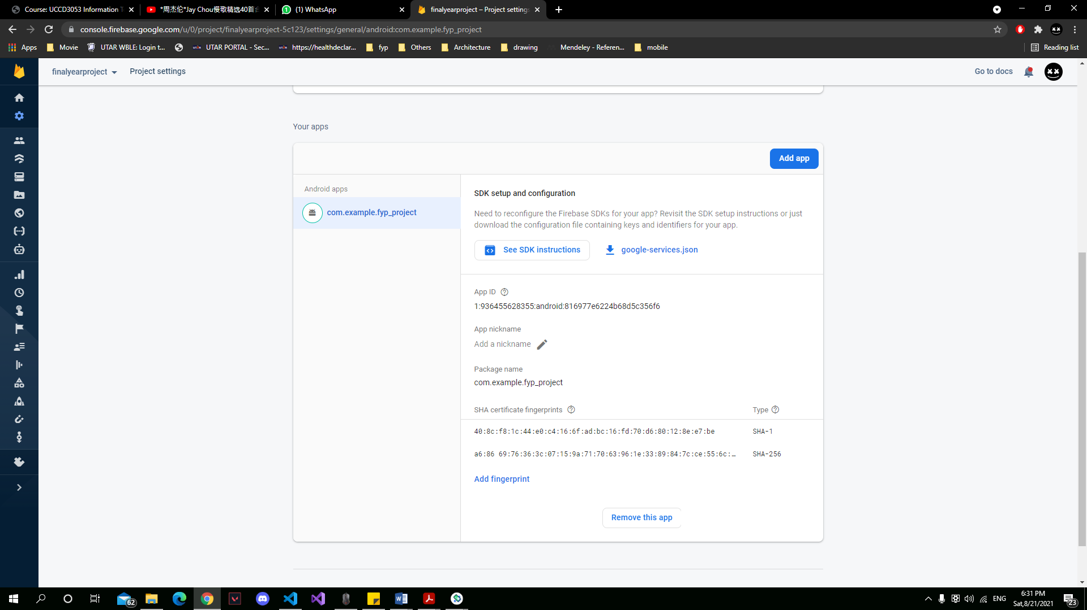

***Figure 4.1.1 Firebase Setup (1)***

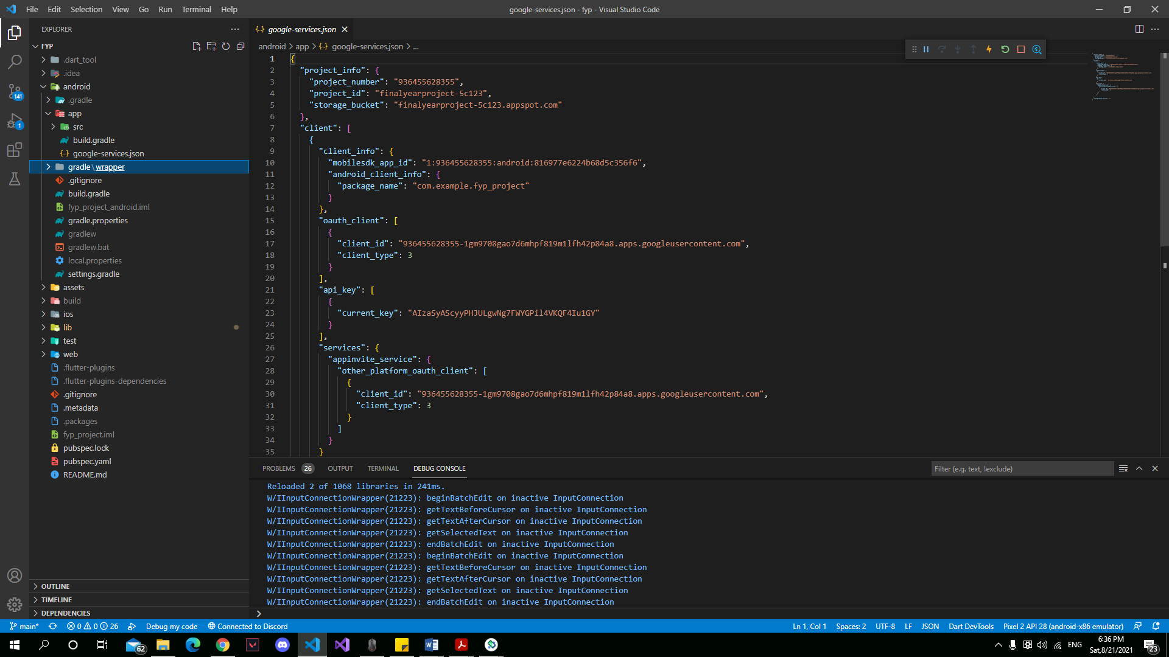

***Figure 4.1.2 Firebase Setup (2)***

Google Firebase is a Google-powered application development platform that allows developers to create iOS, Android and web applications. Firebase provides the authentication method which allow users to sign-in with the email. In this project, Firebase has been used for authentication and as a database.

## 4.2 Start-up User Interface

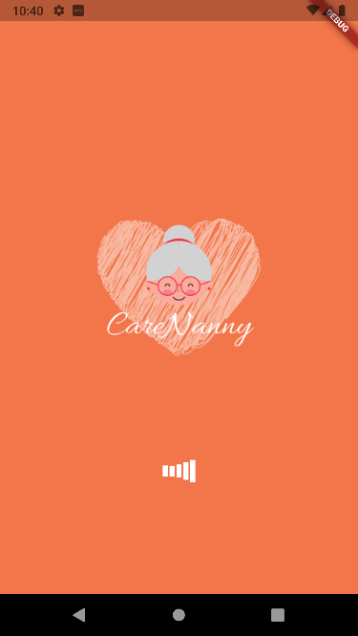 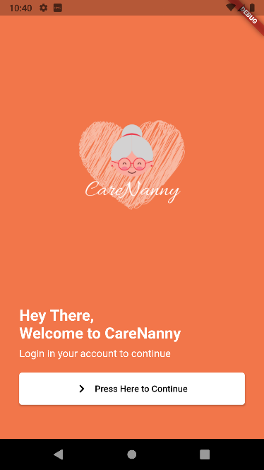

***Figure 4.2.1 Splash Screen Figure 4.2.2 Welcome Page***

The splash screen is set up as the Figure 4.2.1 in the application to notify the users the users that they have successfully start-up the application. Since it is a splash screen to inform the users, it has been designed to have a timeout after two seconds. After two seconds, the screen will be direct to the welcome page which look like Figure 4.2.2 to notify user that they can proceed to the next step.

## 4.3 Sign in User Interface

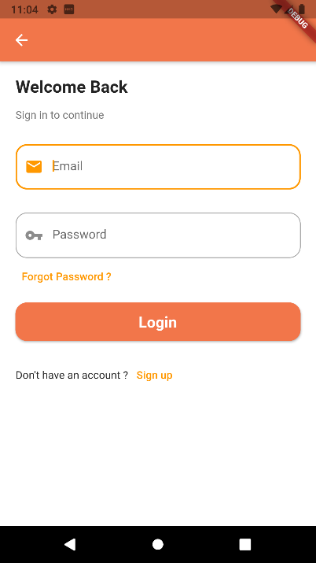

***Figure 4.3.1 Sign in User Interface***

Once the user presses the button at the welcome page, they will be direct to the sign in user interface. After the user key in the email and password, the firebase will verify the existence of the email and the validation of the password before to let the user sign in. Once completed the verification, user will able to sign in to the application. System will verify the user type of user and direct to the respective homepage in Figure 4.6.1 and Figure 4.16.1. If the user does not have an account, they can press the sign-up button at application and then will be direct to the sign-up user interface shown in Figure 4.4.1.

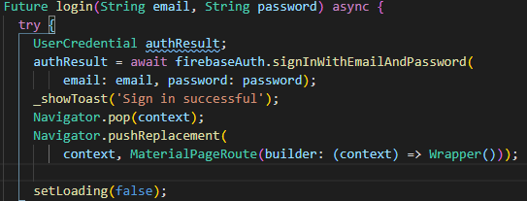

***Figure 4.3.2 Source code of Sign in Function***

## 4.4 Sign-up User Interface

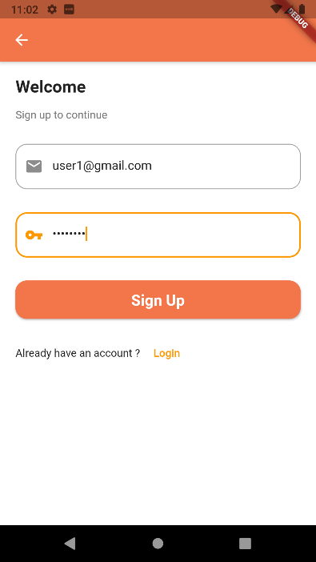

***Figure 4.4.1 Sign-up user interface***

The user key in the email and password for the firebase verification before they sign up. If the email is existed, the system will return the error to user and tell user to key in a new email. Once they successful sign up, user will be direct to the profile filling interface shown in Figure 4.5.1.

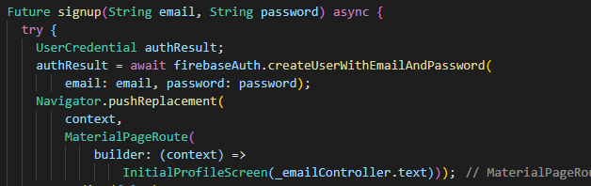

***Figure 4.4.2 Source code for Sign up Function***

## 4.5 Profile Detail User Interface

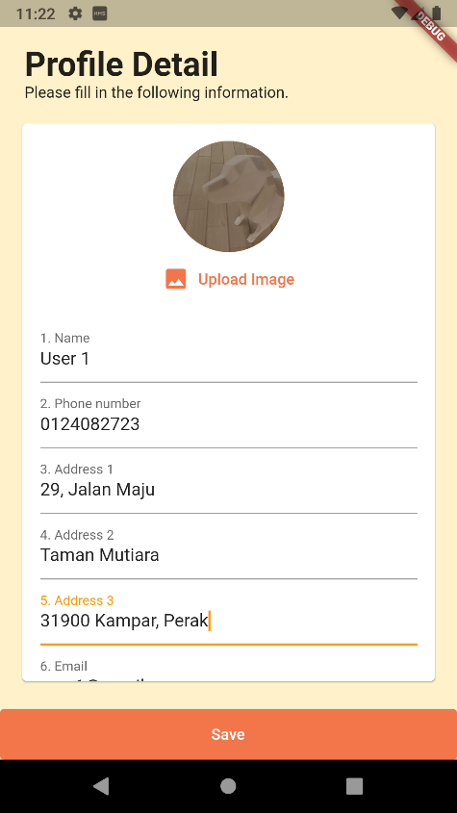 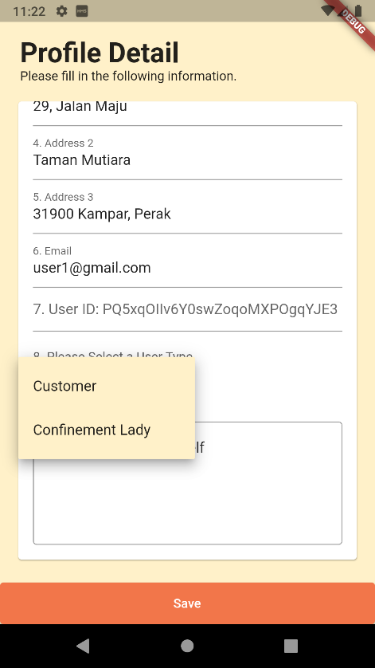

***Figure 4.5.1 Profile Detail User Interface (1)***

***Figure 4.5.2 Profile Detail User Interface (2)***

The user is required to fill in the following profile information as shown in Figure 4.5.1 and Figure 4.5.2 before they can proceed to the next step. The user will be asked to select one of the user types which is: customer or confinement lady before to start their journey in the application. After all the information have been filled, the user can click the save button and will be direct to the homepage shown in Figure 4.6.1. the firebase will store all the information of the user in the database for further usage.

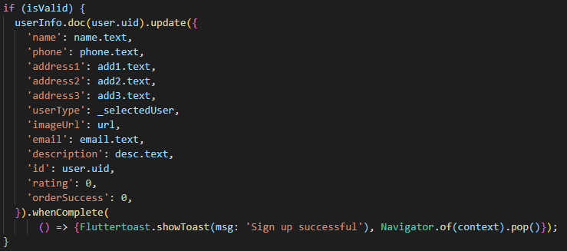

***Figure 4.5.3 Source code for add the data into Firebase***

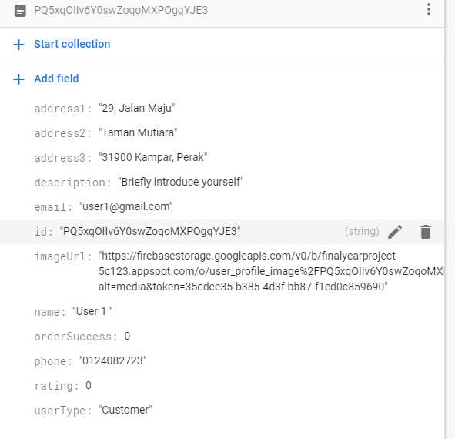

***Figure 4.5.4 Data that stored in Firebase***

## 4.6 Homepage (Customer)

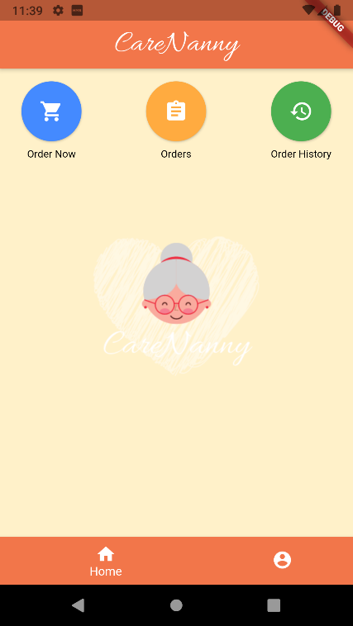

***Figure 4.6.1 Homepage (Customer)***

The user interface of the customer's homepage was shown in the figure above after the first prototype was created. Each button on the prototype gives users access to the designated function. The user only needs to click one time to access into the button’s function. The system will trigger the function and direct the user into the respective user interface which will show at the below after the mobile phone detects the user’s activity in the screen. At the bottom navigation bar, user able to click to direct to the profile interface by clicking the avatar icon just beside the home button.

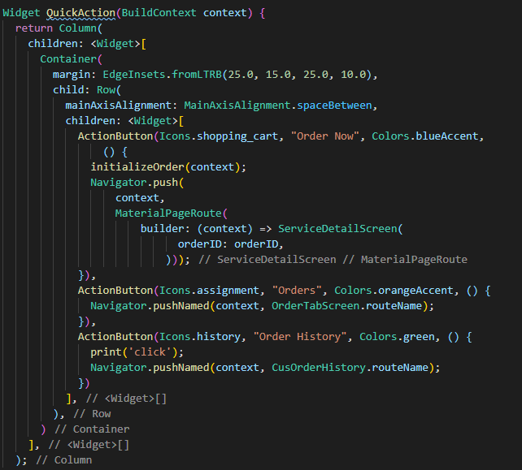

***Figure 4.6.2 Source code of the Buttons***

## 4.7 Profile (Customer)

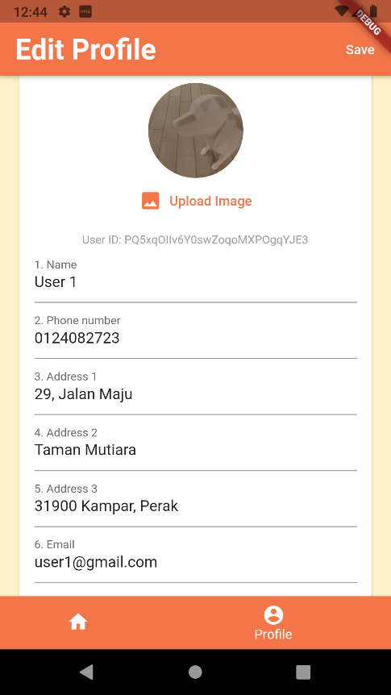 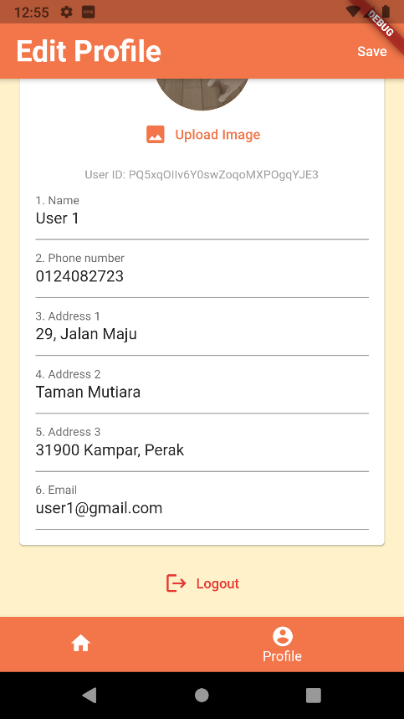

***Figure 4.7.1 Profile Interface (1) Figure 4.7.2 Profile Interface (2)***

The data of the user is retrieved from the Firebase and display at the application shown as Figure 4.7.1. The user able to edit their profile information and upload the profile image in this interface. Users can press the save button at the top right corner once they complete edit their profile. The system will toast a message when successfully update the user information. Users able to logout through the logout button below the profile page.

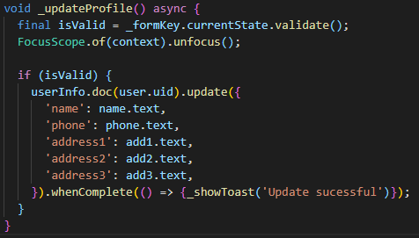

***Figure 4.7.3 Source code for update profile data***

## 4.8 Order Now (Customer)

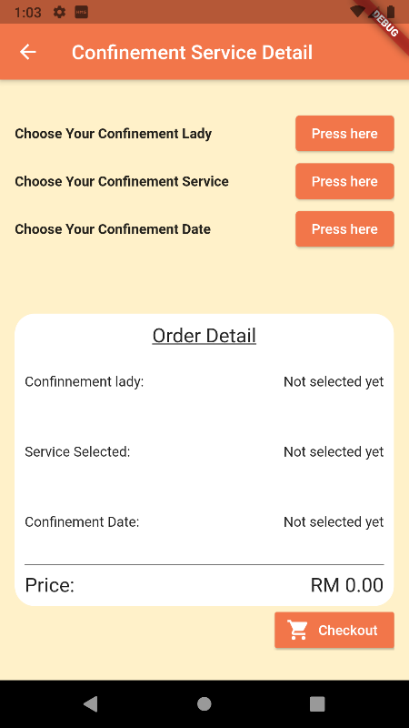 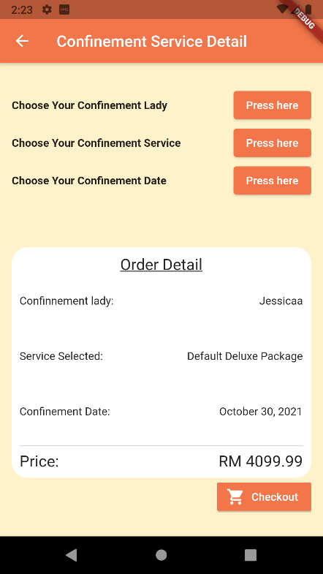

***Figure 4.8.1 Order Now User Interface (1) Figure 4.8.2 Order Now User Interface (2)***

This class is used to let the user select for their confinement lady, service and date they wanted. The respective button shown in the Figure 4.8.1 is allow the user to go to the respective page to select for the confinement service and confinement lady. If the user presses the choose confinement date button, it will pop out the date picker shown in Figure 4.8.3 that allow user to select the date. Figure 4.8.2 is shown when the user success selects all the button. User can click the checkout button to proceed the order now. A toast message will appear to notify user when they successfully place the order.

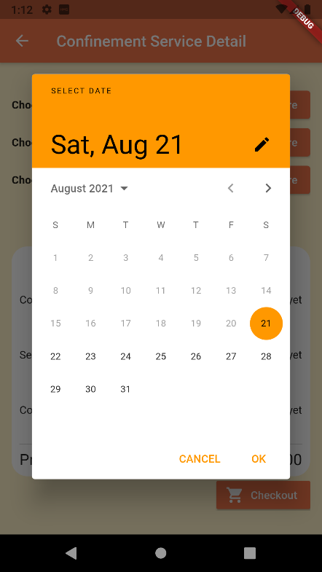 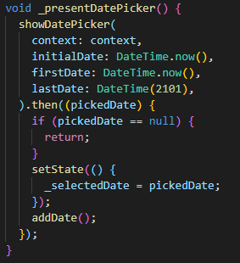

***Figure 4.8.2 Date Picker Figure 4.8.3 Source code for date picker***

## 4.9 Confinement lady Selection Page (Customer)

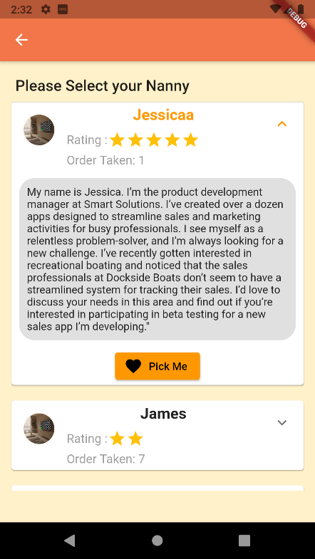

***Figure 4.9.1 Confinement Lady Selection Page***

When the user clicks the select confinement lady button, they will be navigated to this page to select the confinement lady. As you can see from the above figure, the list of available confinement lady will be display as shown as the figure. User able view the rating and order taken by the confinement lady. Besides of that, the confinement lady also wrote down their introduction and working experiences in the description box prepared in the application. User can select the confinement lady by clicking the pick me button just below of the description box. Once they complete, they will be navigated back to the order page in Figure 4.8.1 and the name of the selected confinement lady will also been shown in the Order Detail container.

## 4.10 Service Type User interface (Customer)

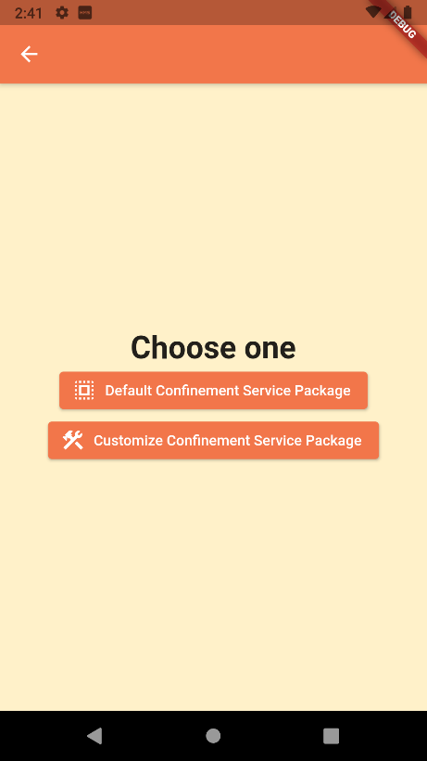

***Figure 4.10.1 Service Type User Interface***

When the user clicks the select confinement service button, they will be direct to this page to choose either default confinement service package or customize confinement service package. Each button will direct the user to the respective page which shown as Figure 4.11.1 and Figure 4.12.1.

## 4.11 Default Confinement Service User Interface (Customer)

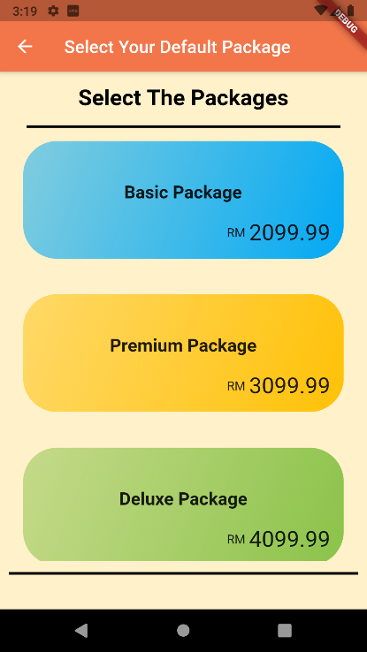 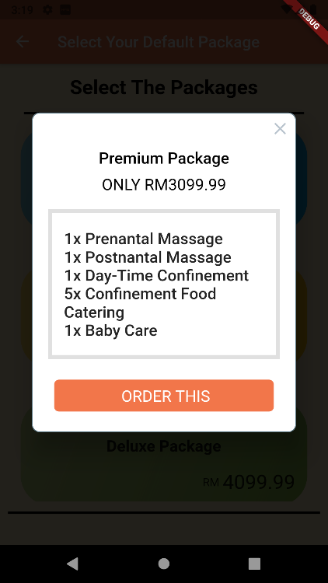

***Figure 4.11.2 Dialog Box***

***Figure 4.11.1 Default Confinement Service User Interface***

Figure 4.11.1 will be shown when the user clicks the default confinement service package button. The user will be asked to select the available default confinement service package that shown in Figure 4.11.1. Once the user clicked one of the packages, the system will pop out the dialog as shown in Figure 4.11.2 that contain the detail of the service package that the user selected. When the user clicks order this button, the service that selected will be added into the order and the data will be stored in a temporary collection path in the firebase.

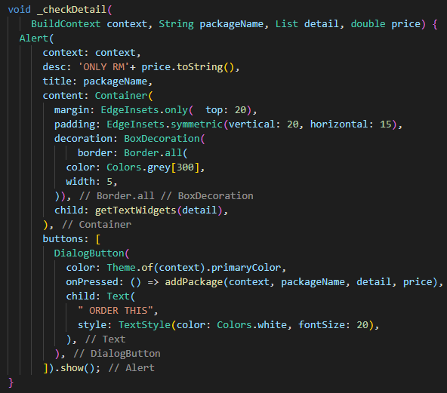

***Figure 4.11.3 Source code of the dialog box***

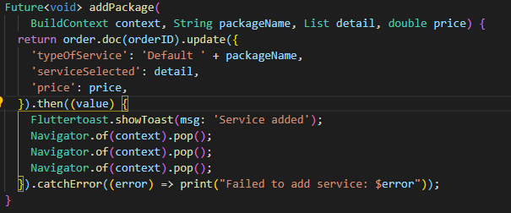

***Figure 4.11.4 Source code of add the default service package***

## 4.12 Customize Confinement Service User Interface (Customer)

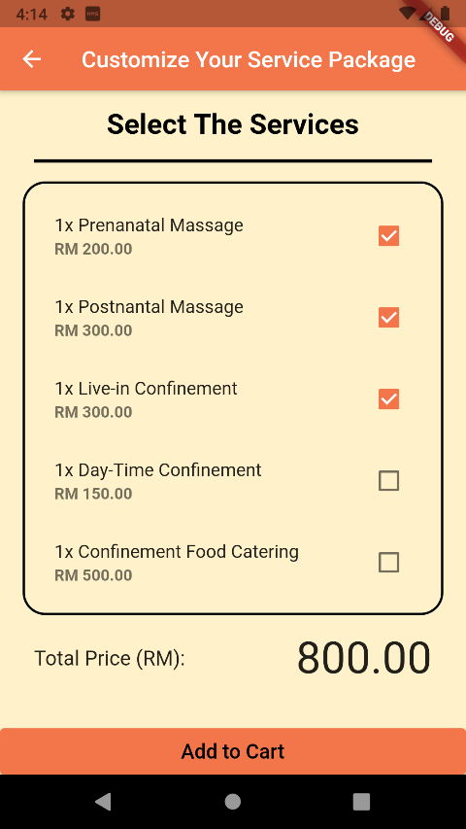

***Figure 4.12.1 Customize Confinement Service User Interface***

Figure 4.12.1 is shown when the customer clicks the customize the confinement service package button. The application will display a list of available confinement service to let the users select their preferable service with the checkbox. Each checkbox has labelled with the confinement service price which will be used to calculate the total price of the service that the users selected. Once the users click on the add to cart button, the chosen service will be placed into the order and the data will be saved in a temporary collection path in the firebase just like the default confinement service selection.

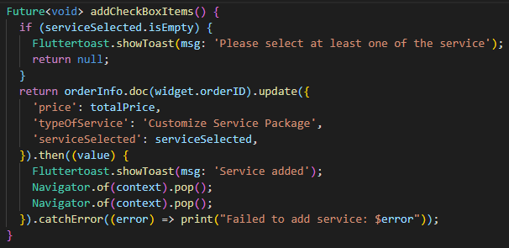

***Figure 4.12.2 Source code of add the customize service package***

## 4.13 Pending Order Page (Customer)

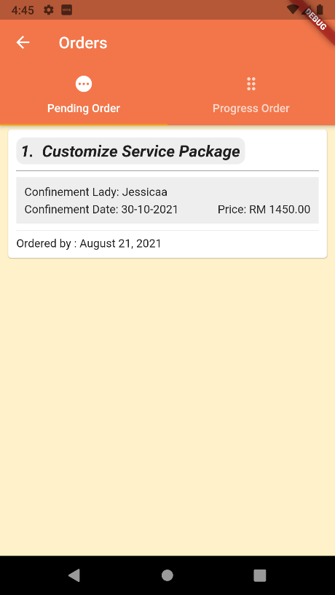 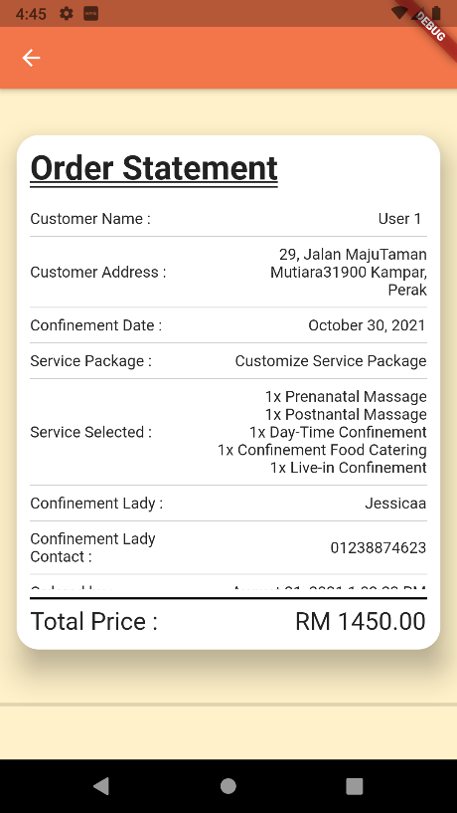

***Figure 4.13.1 Pending Order Page Figure 4.13.1 Pending Order Page Detail***

After the users placed the order, the order will be stored in the pending order database as shown in the Figure 4.13.1 and waiting for the confinement lady accept the order. The user able to single tap the order to view for more detail of the order made. Once the application detect user clicks the order, it will be directed to the order statement page for the user to check more details.

## 4.14 Progress Order Page (Customer)

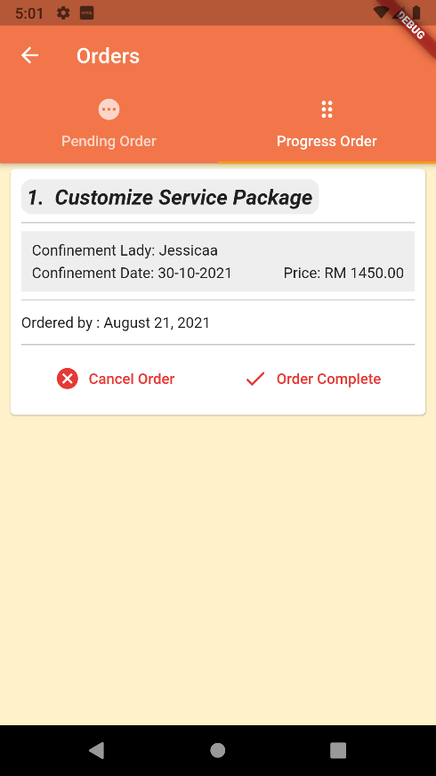 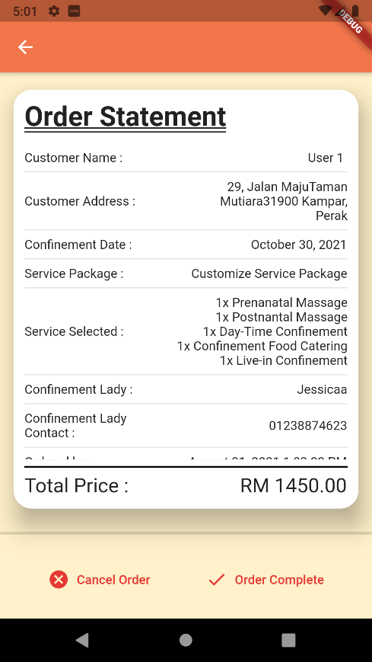

***Figure 4.14.1 Progress Order Page Figure 4.14.2 Progress Order Page Detail***

Once the confinement lady accepts the order, the order in the Figure 4.13.1 will be moved to Figure 4.14.1. The way for the user to view the detail of the order same as the pending order page. If the user wishes to change their mind, they can click the cancel order button to delete order from the system. User can click the order complete button to end the order when the confinement lady is completed their confinement service.

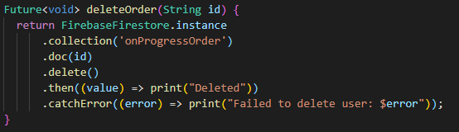

***Figure 4.14.3 Source code to delete the order***

Once user clicks the order complete button, it will pop out the dialog box as shown in Figure 4.13.4 which will ask the user to pick a rating score for the confinement lady and give some comment about the experience of the confinement service of the confinement lady provided. When user clicks the submit button, it will send the rating number and the comment to the system and store it into the database. At the same time, it also will move this order to the customer history page as shown in Figure 4.15.1 and remove it from the progress order page.

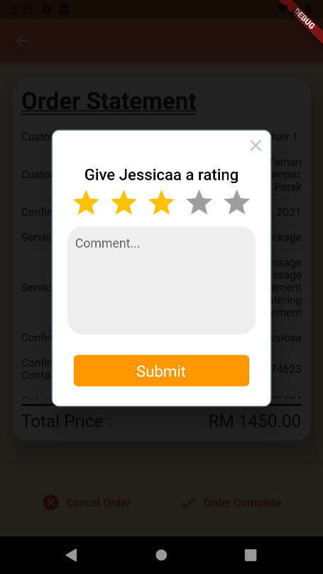

***Figure 4.14.4 Rating dialog***

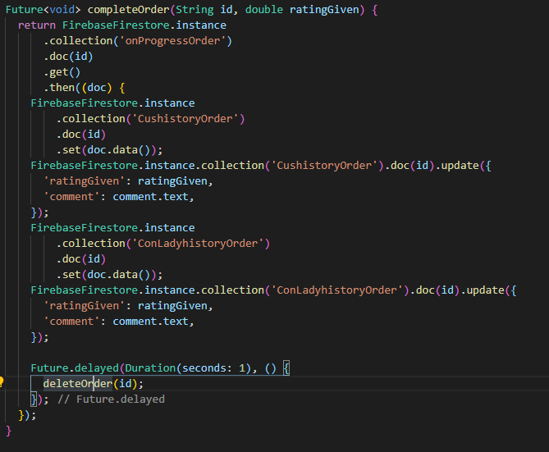

***Figure 4.14.5 Source code of the Submit button***

## 4.15 History Page (Customer)

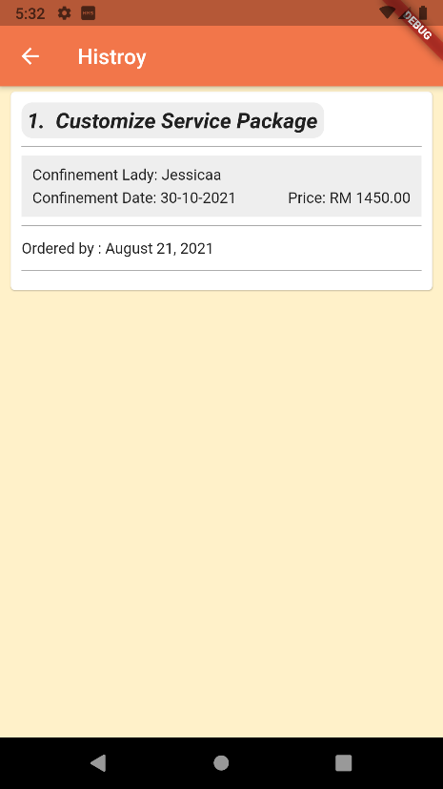 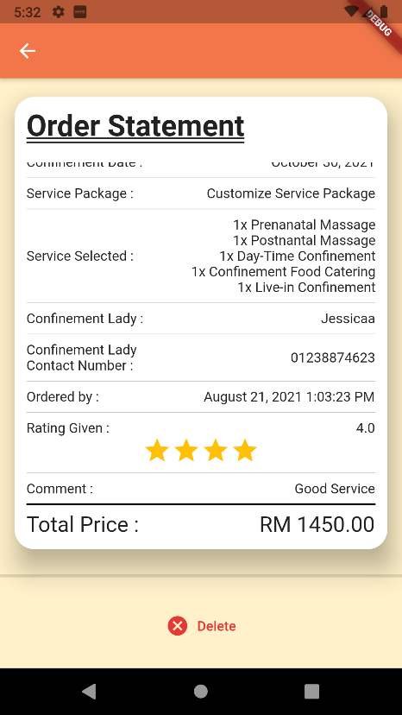

***Figure 4.15.1 History Page Figure 4.15.2 History Page Detail***

The user able to view the history order at the order history button. Once the user clicks the order history button in the homepage, the user will be directed to the history page as shown in Figure 4.15.1 that store the all the completion order. The way for the user to view the detail of the order same as the progress order page. In the Figure 4.15.2, the rating number and the comment is added into the order detail to allow the user view the comment and the star that they give to the confinement lady for future reference purpose. At the bottom part of the order detail, the user also able to delete the history by clicking the delete button.

## 4.16 Homepage (Confinement Lady)

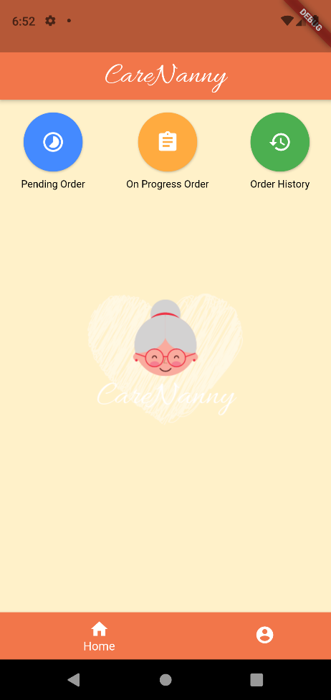

***Figure 4.16.1 Homepage (Confinement Lady)***

The user interface of the confinement lady’s homepage was shown in the figure above after the first prototype was created. Each button on the prototype gives users access to the designated function. The user only needs to click one time to access into the button’s function. The system will trigger the function and direct the user into the respective user interface which will show at the below after the mobile phone detects the user’s activity in the screen. At the bottom navigation bar, user able to click to direct to the profile interface by clicking the avatar icon just beside the home button.

## 4.17 Profile Page (Confinement Lady)

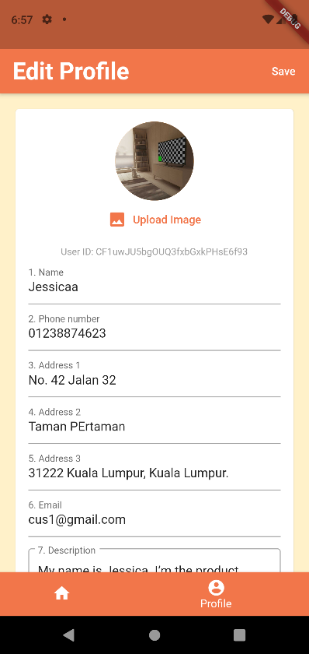 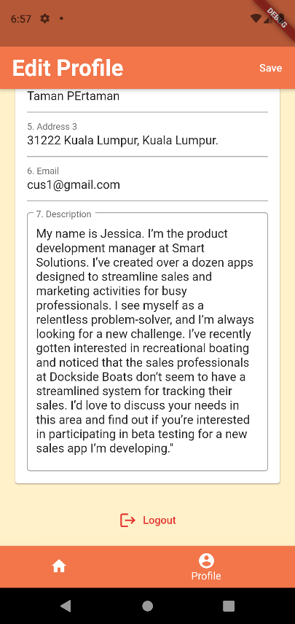

***Figure 4.17.1 Profile Interface (3) Figure 4.17.1 Profile Interface (4)***

The data of the user is retrieved from the Firebase and display at the application shown as Figure 4.17.1. The user able to edit their profile information and upload the profile image in this interface. In the Figure 4.17.1, user can able to add the description to describe themselves to attract the customer. Users can press the save button at the top right corner once they complete edit their profile. The system will toast a message when successfully update the user information. Users able to logout through the logout button below the profile page.

## 4.18 Pending Order Page (Confinement Lady)

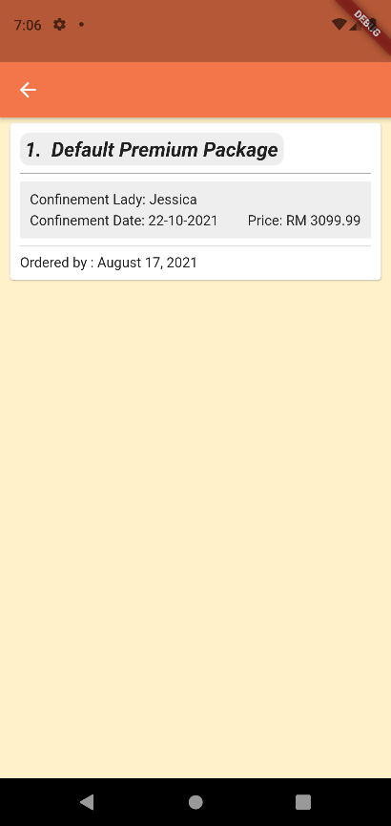 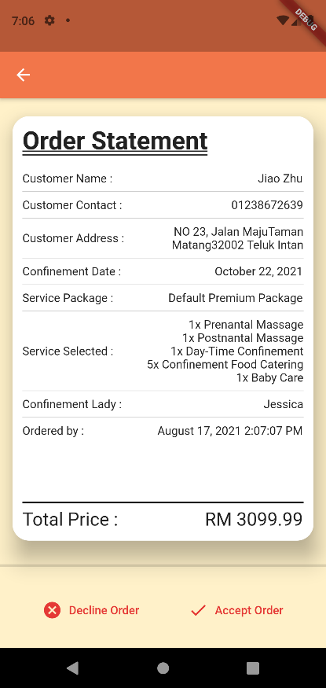

***Figure 4.18.1 Pending Order Page Figure 4.18.2 Pending Order Detail Page***

In the Figure 4.18.2, user able to accept or decline the order by select the button below the order statement. When the user clicks the decline order, the system will remove the customer order from the pending order. If user accept the order, the order will be move to the progress order page.

## 4.19 Progress Order Page (Confinement Lady)

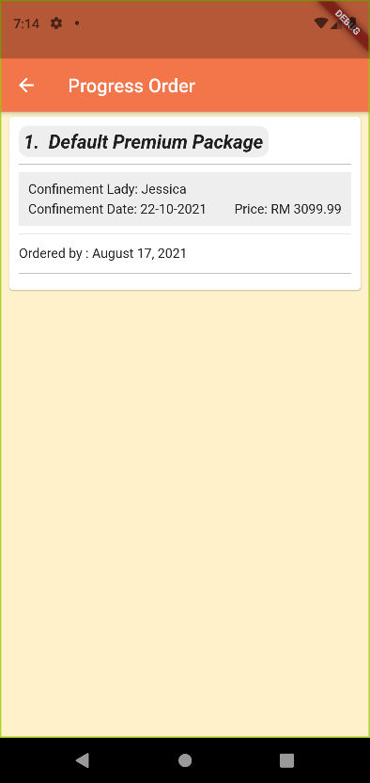 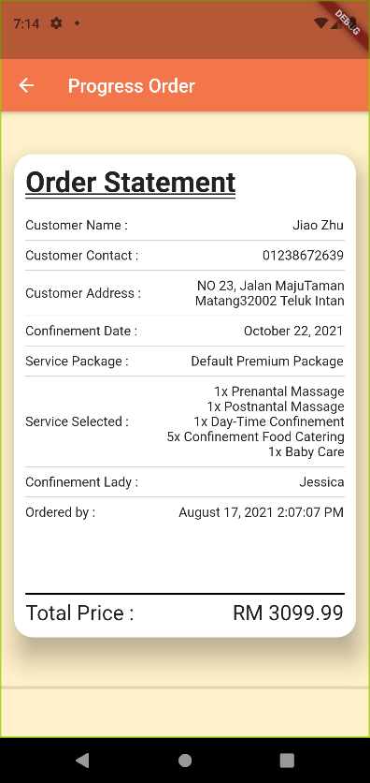

***Figure 4.19.1 Progress Order Page Figure 4.19.2 Progress Order Detail Page***

User able to check their progress order detail in this interface which shown as Figure 4.19.2. Once the customer clicks the complete order, the progress order in this figure will be move to the confinement history page in Figure 4.20.1.

## 4.20 History Page (Confinement Lady)

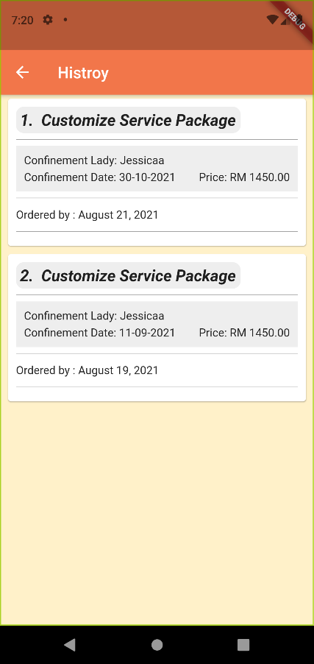 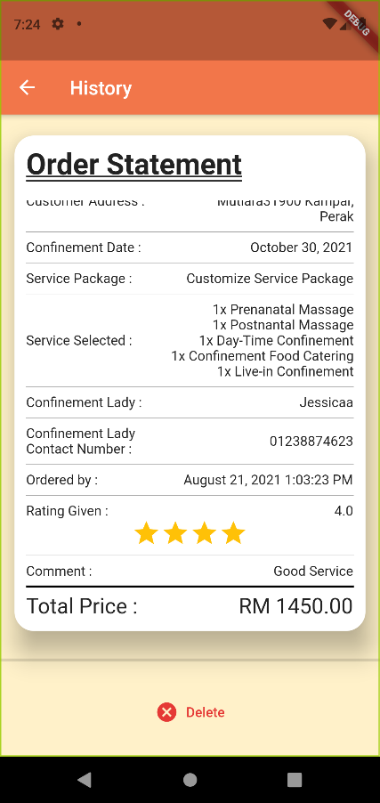

***Figure 4.20.1 History Page Figure 4.20.2 History Detail Page***

The user able to view the history order at the order history button. Once the user clicks the order history button in the homepage, the user will be directed to the history page as shown in Figure 4.20.1 that store the all the completion order. The way for the user to view the detail of the order same as the progress order page. In the Figure 4.20.2, the rating number and the comment is added into the order detail to allow the user view the comment and the star given by the customer. At the bottom part of the order detail, the user also able to delete the history by clicking the delete button.

# Conclusion

In a conclusion, in order to help to solve the problem that the current existing market does not have a mobile-based confinement service application, a e-confinement service application has been developed in this project to provide the users a platform to searching for the confinement lady that providing the confinement service. The objectives of this project are providing the users several features like customizing confinement service package, provide a better navigation system for the confinement lady to search for the user’s location, and implementing the rating system which intended to let the confinement service become better. This project will be developed using Dart programming language associated with the Flutter framework and using the Firebase as the database. It will feature a graphical user interface, 3 main modules which has been mentioned above and miscellaneous modules that will help to improve the user experiences when they using the mobile application. This project is expected to take around two semesters to complete and deliver.

# BIBLIOGRAPHY

1. Fok, D., Aris, I., Ho, J., Lim, S., Chua, M., Pang, W., Saw, S., Kwek, K., Godfrey, K., Kramer, M. and Chong, Y., 2016. A Comparison of Practices During the Confinement Period among Chinese, Malay, and Indian Mothers in Singapore. *Birth*, 43(3), pp.247-254.
2. Vow, T. and Vow, T., 2021. 8 Best Confinement Nanny in Singapore You Should Hire (2020). *The Wedding Vow*. Available at: <https://www.theweddingvowsg.com/confinement-nanny-singapore/> [Accessed 8 March 2021].
3. Confinementcaremalaysia.com. 2021. *Confinement Lady Malaysia | Your One-stop Confinement Care Provider*. Available at: <https://www.confinementcaremalaysia.com/> [Accessed 10 March 2021].
4. First Online Confinement Care Services Platform in Malaysia| 28Days. 2021. *28days-Home*. Available at: <https://28days.my/> [Accessed 10 March 2021].
5. Confinement Angels. 2021*. Confinement Nanny Singapore | Hospital Certified | Confinement Lady*. Available at: <https://confinementangels.com.sg/> [Accessed 10 March 2021].
6. Star Confinement Nanny Agency. 2021*. Star Confinement Nanny Agency - Singapore Confinement Nannies*. Available at: <https://starconfinementnanny.com.sg/> [Accessed 11 March 2021].
7. PEM Confinement Nanny Agency. 2021*. Confinement Nanny Singapore | MOM Licensed Confinement Lady*. Available at: <https://pemconfinement.com/> [Accessed 11 March 2021].
8. Confinement Nanny Singapore. 2021. *The leading confinement nanny agency providing confinement nanny, daytime nanny and babysitter in Singapore.* Available at: <https://www.nannysos.com.sg/> [Accessed 11 March 2021].
9. Balaji, S. & Murugaiyan, M.S., 2012. Waterfall vs. V-Model vs. Agile: A comparative study on SDLC. *International Journal of Information Technology and Business Management*, 2(1), pp.26-30.
10. CherCherTech. 2021. *Introduction To Agile Methodology*. Available at: <https://chercher.tech/jira/agile-methodology> [Accessed 20 March 2021].
11. SDLC, A., 2021*. Agile in SDLC* | Characteristics and Functionality of Agile in SDLC. EDUCBA. Available at: <https://www.educba.com/agile-in-sdlc/> [Accessed 21 March 2021].
12. Visual-paradigm.com. 2021. *Visual Paradigm Product Overview*. Available at: <https://www.visual-paradigm.com/support/documents/vpuserguide/12/13/5963_visualparadi.html> [Accessed 23 March 2021].
13. SearchMobileComputing. 2021. *What is Android Studio?* - Definition from WhatIs.com. Available at: <https://searchmobilecomputing.techtarget.com/definition/Android-Studio> [Accessed 23 March 2021].
14. Code, V. 2021*. Why Visual Studio Code? Code.visualstudio.com*. Available at: <https://code.visualstudio.com/docs/editor/whyvscode> [Accessed 23 March 2021].
15. O’Reilly Online Learning. 2021*. Software Architecture Patterns*. Available at: <https://www.oreilly.com/library/view/software-architecture-patterns/9781491971437/ch01.html> [Accessed 29 March 2021].
16. O'Neill, A., 2021. Malaysia - unemployment rate 1999-2020 | Statista. [online] Statista. Available at: <https://www.statista.com/statistics/319019/unemployment-rate-in-malaysia> [Accessed 12 June 2021]
17. Surve, V. and Here, Y., 2022. Haversine Vs Vincenty: Which is the best?| Neova Tech Solutions. [online] Neova Tech Solutions : We are startup specialists. Available at: <https://www.neovasolutions.com/2019/10/04/haversine-vs-vincenty-which-is-the-best/> [Accessed 6 April 2022].
18. Kettle, S., 2022. Distance on an ellipsoid: Vincenty's Formulae. [online] Distance on an ellipsoid: Vincenty's Formulae. Available at: <https://community.esri.com/t5/coordinate-reference-systems-blog/distance-on-an-ellipsoid-vincenty-s-formulae/ba-p/902053> [Accessed 7 April 2022].
19. GitHub. 2022. GitHub - microsoft/vscode: Visual Studio Code. [online] Available at: <https://github.com/microsoft/vscode> [Accessed 7 April 2022].
20. Android Developers. 2022. Download Android Studio and SDK tools | Android Developers. [online] Available at: <https://developer.android.com/studio?gclid=Cj0KCQjwl7qSBhD-ARIsACvV1X0HA6kDGmJJ8T9Sn23FcF-DCVUaZuIhSONgx4CptIg4lvmHL5VC93EaAhQvEALw_wcB&gclsrc=aw.ds> [Accessed 7 April 2022].
21. Firebase. 2022. Firebase. [online] Available at: <https://firebase.google.com/?gclid=Cj0KCQjwl7qSBhD-ARIsACvV1X1wcXux6jAwirjVQlA8dae8q7ZbgdV5XvW34E90tUZbVzOdCnolh_EaAnlGEALw_wcB&gclsrc=aw.ds> [Accessed 7 April 2022].

# Appendix A Biweekly Report

**FINAL YEAR PROJECT WEEKLY REPORT**

*(Project I / ~~Project II~~)*

|  |  |
| --- | --- |
| **Trimester, Year: Y3S1** | **Study week no.:2** |
| **Student Name & ID: Chia Kai Yi 18ACB01343** | |
| **Supervisor:Ts. Yeck Yin Ping** | |
| **Project Title: E-Confinement Service System** | |

|  |
| --- |
| **1. WORK DONE**  [Please write the details of the work done in the last fortnight.]  Reevaluate the problem, scope, objectives and background information of chapter 1.  Draw the system Framework, use case diagram, activity diagram. |
| **2. WORK TO BE DONE**  Draw the sequences diagram.  Study the dart coding language. |
| **3. PROBLEMS ENCOUNTERED**  No problem encountered. |
| **4. SELF EVALUATION OF THE PROGRESS**  -Expected to complete all the diagram at week 3. |



_________________________

Supervisor’s signature Student’s signature

**FINAL YEAR PROJECT WEEKLY REPORT**

*(Project I / ~~Project II~~)*

|  |  |
| --- | --- |
| **Trimester, Year: Y3S1** | **Study week no.: 4** |
| **Student Name & ID: Chia Kai Yi 18ACB01343** | |
| **Supervisor:Ts. Yeck Yin Ping** | |
| **Project Title: E-Confinement Service System** | |

|  |
| --- |
| **1. WORK DONE**  [Please write the details of the work done in the last fortnight.]  Complete the sequence diagram. |
| **2. WORK TO BE DONE**  Display the screen of customer choose the confinement service i.e. Select the default and customize confinement service package.  Study the way of implement firebase into the system. |
| **3. PROBLEMS ENCOUNTERED**  No problem encountered. |
| **4. SELF EVALUATION OF THE PROGRESS**  -Expected to complete the WORK TO BE DONE before week 6. |



_________________________

Supervisor’s signature Student’s signature

**FINAL YEAR PROJECT WEEKLY REPORT**

*(Project I / ~~Project II~~)*

|  |  |
| --- | --- |
| **Trimester, Year: Y3S1** | **Study week no.:6** |
| **Student Name & ID: Chia Kai Yi 18ACB01343** | |
| **Supervisor:Ts. Yeck Yin Ping** | |
| **Project Title: E-Confinement Service System** | |

|  |
| --- |
| **1. WORK DONE**  [Please write the details of the work done in the last fortnight.]   * Study the way of implement firebase into the system. * Display the screen of customer choose the confinement service i.e. Select the default and customize confinement service package. * Login authentication and signup authentication * Partial database done implement |
| **2. WORK TO BE DONE**  **-** Complete the database of the system  - implementing the form to let the user fill in the personal info. |
| **3. PROBLEMS ENCOUNTERED**  No problem encountered. |
| **4. SELF EVALUATION OF THE PROGRESS** |



_________________________

Supervisor’s signature Student’s signature

**FINAL YEAR PROJECT WEEKLY REPORT**

*(Project I / ~~Project II~~)*

|  |  |
| --- | --- |
| **Trimester, Year: Y3S1** | **Study week no.:8** |
| **Student Name & ID: Chia Kai Yi 18ACB01343** | |
| **Supervisor:Ts. Yeck Yin Ping** | |
| **Project Title: E-Confinement Service System** | |

|  |
| --- |
| **1. WORK DONE**  [Please write the details of the work done in the last fortnight.]   * Completed first objective. * Complete the form to receive user information. * Completed the profile of both confinement lady and customer. * Done setting up database of the application. |
| **2. WORK TO BE DONE**   * Implement the rating system of the confinement lady. |
| **3. PROBLEMS ENCOUNTERED**  No problem encountered. |
| **4. SELF EVALUATION OF THE PROGRESS** |



_________________________

Supervisor’s signature Student’s signature

**FINAL YEAR PROJECT WEEKLY REPORT**

*(Project I / ~~Project II~~)*

|  |  |
| --- | --- |
| **Trimester, Year: Y3S1** | **Study week no.: 10** |
| **Student Name & ID: Chia Kai Yi 18ACB01343** | |
| **Supervisor:Ts. Yeck Yin Ping** | |
| **Project Title: E-Confinement Service System** | |

|  |
| --- |
| **1. WORK DONE**  [Please write the details of the work done in the last fortnight.]   * Implemented rating system of the confinement lady. |
| **2. WORK TO BE DONE**   * Completing the documentation of the report. * Design the poster |
| **3. PROBLEMS ENCOUNTERED**  No problem encountered. |
| **4. SELF EVALUATION OF THE PROGRESS** |



_________________________

Supervisor’s signature Student’s signature

# Appendix B Poster

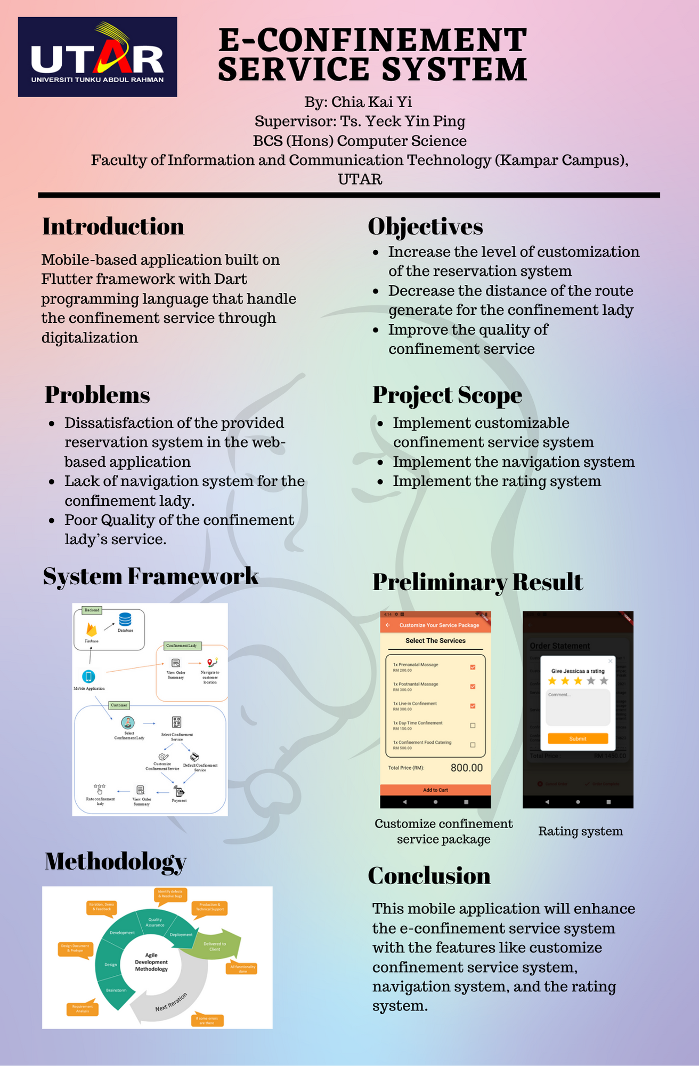

# Appendix C Plagiarism Check Result

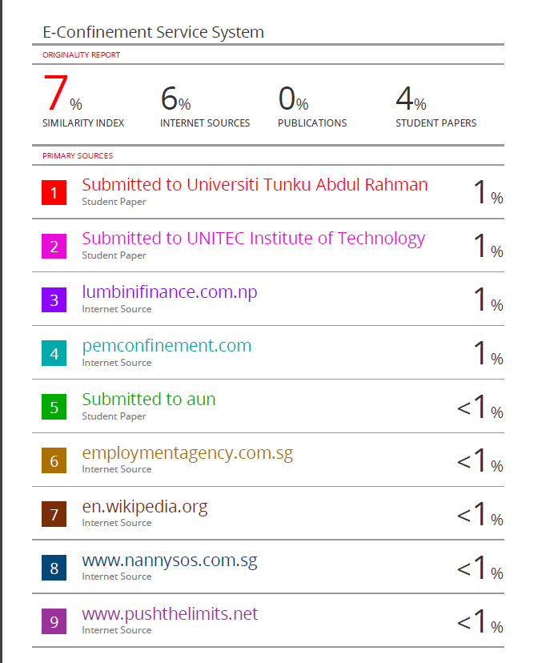

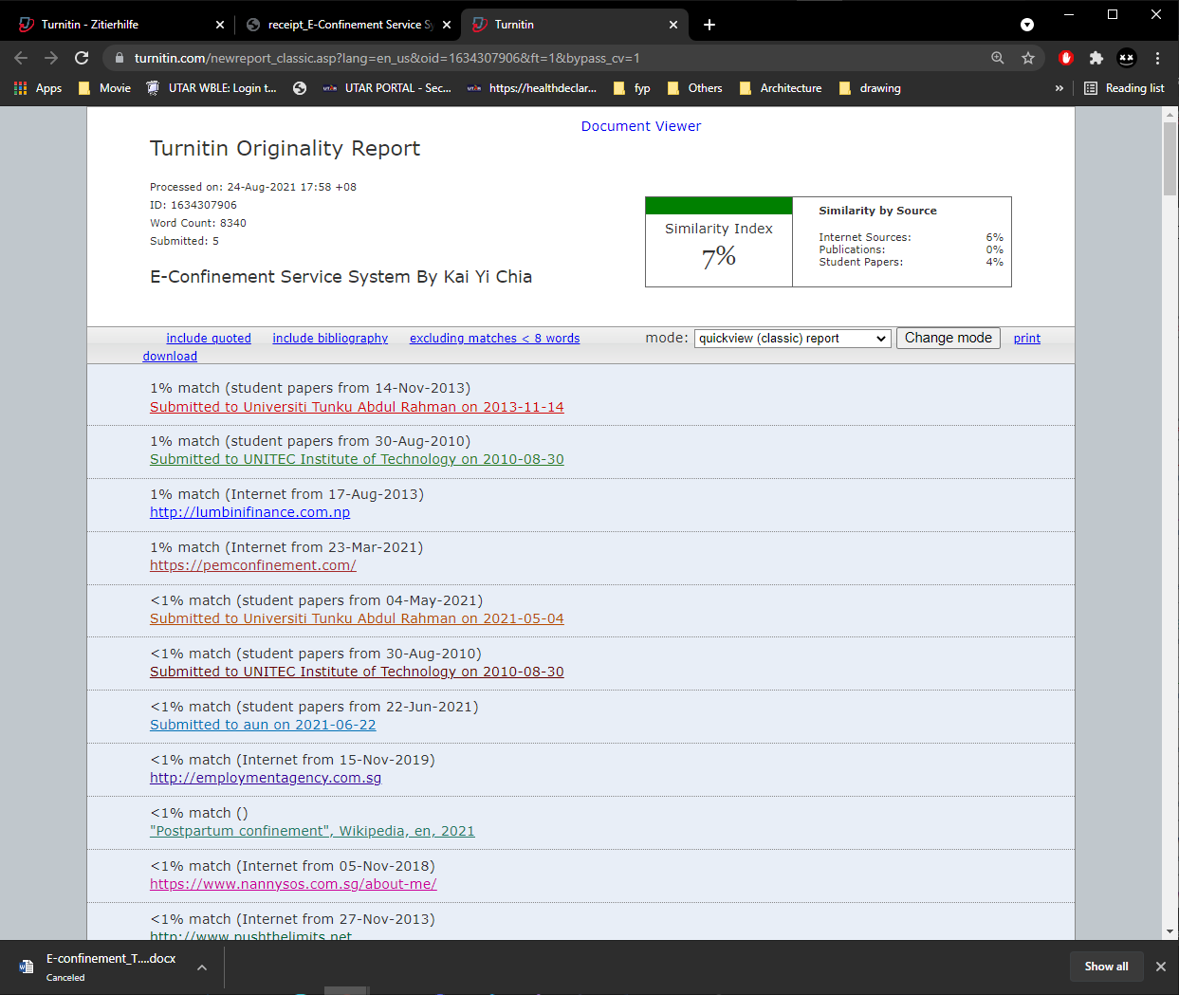

|  |  |  |  |
| --- | --- | --- | --- |
| **Universiti Tunku Abdul Rahman** | | | |
| **Form Title : Supervisor’s Comments on Originality Report Generated by Turnitin for Submission of Final Year Project Report (for Undergraduate Programmes)** | | | |
| Form Number: FM-IAD-005 | Rev No.: 0 | Effective Date: 01/10/2013 | Page No.: 1of 1 |



|  |  |
| --- | --- |
| **Full Name(s) of Candidate(s)** | Chia Kai Yi |
| **ID Number(s)** | 18ACB01343 |
| **Programme / Course** | Bachelor of Computer Science |
| **Title of Final Year Project** | E-Confinement Service System |

**FACULTY OF INFORMATION AND COMMUNICATION TECHNOLOGY**

|  |  |
| --- | --- |
| **Similarity** | **Supervisor’s Comments (Compulsory if parameters of originality exceeds the limits approved by UTAR)** |
| **Overall similarity index: 7 %**  **Similarity by source** Internet Sources: _______6________%  Publications: _____0____ %  Student Papers: _____4____ % |  |
| **Number of individual sources listed** of more than 3% similarity: 0 |  |
| **Parameters of originality required and limits approved by UTAR are as Follows:**  **(i) Overall similarity index is 20% and below, and**  **(ii) Matching of individual sources listed must be less than 3% each, and**  **(iii) Matching texts in continuous block must not exceed 8 words**  ***Note: Parameters (i) – (ii) shall exclude quotes, bibliography and text matches which are less than 8 words.*** | |

Note Supervisor/Candidate(s) is/are required to provide softcopy of full set of the originality report to Faculty/Institute

***Based on the above results, I hereby declare that I am satisfied with the originality of the Final Year Project Report submitted by my student(s) as named above.***

______________________________ ______________________________

|  |  |  |
| --- | --- | --- |
| Signature of Supervisor |  | Signature of Co-Supervisor |
| Name: __________________________ |  | Name: __________________________ |
| Date: ___________________________ |  | Date: ___________________________ |

# Appendix D FYP 1 Checklist



**UNIVERSITI TUNKU ABDUL RAHMAN**

FACULTY OF INFORMATION & COMMUNICATION TECHNOLOGY (KAMPAR CAMPUS)

**CHECKLIST FOR FYP1 THESIS SUBMISSION**

|  |  |
| --- | --- |
| Student Id | 18ACB01343 |
| Student Name | CHIA KAI YI |
| Supervisor Name | Ts. Yeck Yin Ping |

|  |  |
| --- | --- |
| **TICK (√)** | **DOCUMENT ITEMS**  Your report must include all the items below. Put a tick on the left column after you have checked your report with respect to the corresponding item. |
| √ | Title Page |
| √ | Signed form of the Declaration of Originality |
| √ | Abstract |
| √ | Table of Contents |
| √ | List of Figures (if applicable) |
| √ | List of Tables (if applicable) |
|  | List of Symbols (if applicable) |
| √ | List of Abbreviations (if applicable) |
| √ | Chapters / Content |
| √ | Bibliography (or References) |
| √ | All references in bibliography are cited in the thesis, especially in the chapter of literature review |
| √ | Appendices (if applicable) |
| √ | Poster |
| √ | Signed Turnitin Report (Plagiarism Check Result – Form Number: FM-IAD-005) |

*Include this form (checklist) in the thesis (Bind together as the last page)

|  |  |
| --- | --- |
| I, the author, have checked and confirmed all the items listed in the table are included in my report.    (Signature of Student)  Date:25/8/2021 | Supervisor verification. Report with incorrect format can get 5 mark (1 grade) reduction.  ______________________  (Signature of Supervisor)  Date: |